*Article*

**Gear shifting in hyperthermophylic Archaea**

**Yanfei Zhang1, Thierry D. G. A. Mondeel1, Jacky L. Snoep2,3,4, Bettina Siebers5 and Hans V. Westerhoff1,3,4\***

1 Synthetic Systems Biology and Nuclear Organization, Swammerdam Institute for Life Sciences,   
University of Amsterdam, 1098 XH Amsterdam, The Netherlands; y.zhang2@uva.nl (Y.Z.)

2 Department of Biochemistry, University of Stellenbosch, Stellenbosch 7602, South Africa; j.l.snoep@vu.nl

3 The Manchester Centre for Integrative Systems Biology, Manchester Institute for Biotechnology,   
School for Chemical Engineering and Analytical Science, University of Manchester, Manchester M1 7DN, UK

4 Department of Molecular Cell Physiology, Vrije Universiteit Amsterdam, De Boelelaan 1085,   
1081 HV Amsterdam, The Netherlands

5 Molecular Enzyme Technology and Biochemistry (MEB), Biofilm Centre, Centre for Water and Environment Research (CWE), University Duisburg—Essen, Universitätsstr. 5, 45141 Essen, Germany; bettina.siebers@uni-due.de (B.S.)

**\*** Correspondence: H.V.Westerhoff@uva.nl; Tel.: +31-20-6 143163

Received: date; Accepted: date; Published: date

**Abstract:** The well characterized thermoacidophilic *Sulfolobus solfataricus* (*S. solfataricus*) thrives in extreme environments at temperatures ranging from 60 to 90 °C and pH between 2 and 4. We here focus not so much on the challenge posed by each of these individual conditions, but on the challenge of the variation in those conditions. We examine whether a phenomenon we call ‘gear shifting’ could be at play. We do this in four different ways: (i) We examine whether thermodynamically such gear shifting is possible and could optimize the organism’s fitness. (ii) We submit the organism’s genome-wide metabolic map (Ulas et al., 2012) to Flux Balance Analysis to examine whether such gear shifting could correspond to changes in optimal flux pattern with respect to altering the growth requirement of ATP (Gibbs energy) relative to pyruvate (Carbon). (iii) We examine whether the enzyme kinetic properties of one of the organism’s metabolic networks would make it shift gears when subjected to varying ATP demands. (iv) We examine whether the transcriptome changes observed when changing the growth temperature should be expected to cause gear shifting. Performing the flux balance analysis on the genome-sequence based metabolic map, we find a diversity of possible flux patterns with 8 different ATP yields. Using the transcriptome as basis, we find that also the shifts between expressed pathways suggest the operation of various parallel metabolic routes operating at different ATP costs or yields. In the non-equilibrium thermodynamic analysis, we show how transitions between flux patterns could be beneficial for the flux of ATP synthesis. We identify a mode of continuous variation of the ATP/catabolism stoichiometry that should be optimal for the organism if it is differentially stressed energetically. The simulations with an *in silico* kinetic replica show that the ATP/ADP ratio should be a strong determinant of the relative fluxes through the glyceraldehyde-3-phosphate dehydrogenase (GAPDH) plus phosphoglycerate kinase (PGK) pathway on the one hand and the non-phosphorylating glyceraldehyde-3-phosphate dehydrogenase (GAPN) pathway. With an increase in the ATP/ADP ratio, the flux through GAPDH decreased, whilst the flux through GAPN increased monotonically. Flux balance analysis further shows that with this different pathway allocation the harvest of Gibbs energy or biomass changes. Likewise, according to FBA, at different oxygen concentrations different electron transfer pathways may be used to best achieve certain objectives. We identify these phenomena as ‘gear shifting’, which should enable organisms’ to enhance their fitness under conditions of time-variant challenges.

**Keywords:** Hyperthermophylic archaea; flux balance analysis; gear shifting; ATP maintenance; flux distributions; oxidases; non-equilibrium thermodynamics; metabolic rewiring; variable stoichiometries

**1. Introduction**

Gear shifting is best known from driving. Depending on the change of road conditions, the driver or the car itself needs to shift between gears. When driving on a flat highway, the highest gear will give the highest speed, while when driving uphill, shifting to a lower gear may increase the speed, as it is necessary to provide enough force to the wheels: the optimal gear is not always the highest. Does such gear shifting exist in living organisms as well? *Clostridium ljungdahlii* contains alternatives in its genome for various redox reactions. These produce different ATP/acetate ratios and have been proposed to affect gear shifting (Mondeel et al., 2016).

A phenomenon similar to gear shifting exists in the emergence of many cancer cell types. Cancer cells tend to employ glycolysis or glutaminolysis to lactate rather than oxidative phosphorylation to provide ATP, even when oxygen is present, which is called Warburg or WarburQ effect (Damiani et al., 2017). Weglarz-Tomczak et al (2021) found that cell-nutrition impacted the Warburg effect in hepatocellular carcinoma cells. In the yeast *Saccharomyces cerevisiae*, fermentation is a major pathway for Gibbs energy harvest, even under aerobic conditions. However, when glucose becomes scarce, ethanol produced during fermentation is used as a carbon source, requiring a shift to respiration (Gasmi et al., 2014). These phenomena are not quite the same as gear shifting as they also involve switches in catabolic products: We shall here examine the related phenomenon of the shifting between different metabolic routes that connect the same substrate (such as glucose and oxygen) and the same product (-couple; such as CO2 and water). We hypothesize that such gear shifting is exquisitely important when energetic challenges arise such as a lowered Gibbs energy in the catabolic substrates, lowered Gibbs energy differences across catabolic reactions at high temperature due to negative reaction enthalpies, or increased ADP phosphorylation free energy.

In 1990, Archaea were identified as the third kingdom of life based on their 16S rRNA (Woese, 1990). Many properties distinguish them from most Bacteria and Eukarya and many through not all Archaea manage to survive conditions that are extreme for most Eukarya and Bacteria. The thermophilic Archaea even thrive on temperatures between 60 and 80 °C, while hyperthermophiles live in the temperature range from 80 to 113 °C (Stetter, 1999). Growth at high temperatures and low pH offers various challenges. Beyond pH and temperature themselves, these include spontaneous decomposition of metabolic substrates and intermediates, possibly including ATP and ADP, reduced oxygen tension and compromised substrate uptake. In order to solve these problems, extremophiles need to adopt special strategies. In this paper we ask whether in principle gear shifting could be one of these.

*S. solfataricus*, one of the best studied (hyper)thermophilic archaea optimally and growing at 80 °C (60-90 °C) and pH 2-4, will be focused on in this paper. This organism contains the non-phosphorylating glyceraldehyde-3-phosphate dehydrogenase (GAPN), which catalyzes the direct oxidation of glyceraldehyde-3-phosphate to 3-phosphoglycerate by NADP. The enzyme bypasses adenosine 5′-triphosphate (ATP) formation by substrate-level-phosphorylation of ADP via phosphoglycerate kinase (PGK). The kinetic parameters of the relevant enzymes have been determined experimentally and we therefore could implement kinetic modelling to demonstrate that at high temperatures this organism should be expected mainly to use the GAPDH and PGK pathway in the gluconeogenic direction, with the GAPN functioning in the catabolic direction (Zhang et al., 2017). As we shall show below, this is a form of gear shifting.

The fluxes through these pathways should however not only be determined by these three enzymes but also by their metabolic environment and ultimately the genome wide metabolism in the organism. And due to the lack of kinetic parameters for most enzymes, it is impossible to construct a genome-wide kinetic model. This left much of the issue unsettled.

Flux balance analysis (FBA) is a mathematical method for comprehending the possibilities for steady flow through a metabolic network and there is sufficient information (Ulas et al., 2012) for FBA to be able to deal with genome-wide metabolic fluxes in *S. solfataricus*. In the present study, we shall show, more in general, how FBA can be used to address gear shifting. Using the genome wide metabolic map of *S. solfataricus* we identify 4 different gear settings already in anaerobic catabolism alone and 8 in total and then explain on this genome wide basis why this organism is an obligate aerobe. Using non equilibrium thermodynamics we show that there should be an optimum gear setting from the perspective of maximizing growth rate and that this setting may change when the growing becomes tough thermodynamically. We shall also map the transcriptome data of *S. solfataricus* growing at different temperatures to the genome wide metabolic map to verify the existence of gear shifting between different pathways.

**2. Materials and Methods**

*2.1. Kinetic model demonstrating gear shifting in S. solfataricus*

Our starting point was the model published in 2017 by our group (Zhang et al., 2017). By varying the rate constant of the ATPase in the model, different ATP hydrolysis (or ‘NGAM’: Non Growth rate associated Maintenance) fluxes, as well as different ATP/ADP ratios and different fluxes through the different catabolic pathways were obtained. We used Copasi (COPASI 4.16, available online: http://copasi.org/News/2015/08/19/Release/) throughout for the modelling. This software and the model files can be found in the Github repository under the folder name “Models”.

*2.2. Genome-scale reconstruction of S. solfataricus*

Our starting point was the previously published genome-scale metabolic map (GEMM) of *S. solfataricus* by (Wolf et al., 2016). We obtained the SBML file of the reconstruction through <https://fairdomhub.org/models/225> on April 24th 2018. We changed the reactions shown in Table 1. We did this to deal with proton imbalance and the different written forms for the protons (In the original GEMM, both H+_rc and H+_ex represent the protons outside the cell). We added Psi to deal explicitly with the transmembrane electric potential difference (outside minus inside; in terms of number of elementary charges). Psi represents electric charge moved outward across the membrane, whilst H+_rc then represents only the acidity aspect of the extracellular protons (Psi + H+_rc is the electric extracellular proton). Psi divided by the electric capacity of the membrane equals the electric potential generated across it (outside minus inside). To check charge balance of each in each compartment to Psi should be replaced by Psi+ - Psi+_ex. In actual fact, the charge balance should effected by all transport reactions to together. The implementation of this variable Psi eliminates the requirement of the intracellular chemical reactions to be formulated precisely in terms of their proton and charge stoichiometries. Besides the above modifications we also changed the reactions catalyzed by glyceraldehyde-3-phosphate dehydrogenase into reversible ones. The file named as “modification of the original model” can be found in the Github repository under the folder name “data”. Table 1 shows how the reactions were modified.

**Table 1.** The modified reactions. Before using the model, we modified some reactions because of a proton imbalance problem and in order to deal with the transmembrane electric potential difference (Psi).

|  |  |  |  |
| --- | --- | --- | --- |
| Reaction id | Original reaction | After changing | Reasons |
| carb_degra_1.2.1.26_R01752 | D-glyceraldehyde + H2O + NADP+ 🡪 D-glycerate + H+ + NADPH | D-glyceraldehyde + H2O + NADP+ 🡪 D-glycerate- + 2.0 H+ + NADPH ¹ | Proton imbalance |
| oxp_redox_1.10.3.13_soxABCD_TRANS__RXN__240 | 6.0 H+ + 0.5 oxygen + representative_quinol 🡪 4.0 H+_rc + H2O + representative_quinone | 4.0 H+ + 0.5 oxygen + representative_quinol 🡪 4.0 H+_ex + H2O + 4.0 Psi + representative_quinone ² | Unification of the proton written forms and adding of Psi |
| oxp_redox_1.10.3.13_soxM_TRANS__RXN__240 | 2.0 H+ + 0.5 oxygen + representative_quinol --> 2.0 H+_rc + H2O + representative_quinone | 2.0 H+ + 0.5 oxygen + representative_quinol --> 2.0 H+_ex + H2O + 2.0 Psi + representative_quinone | Unification of the proton written forms and adding of Psi |
| oxp_redox_1.10.3.13_doxABCDE_TRANS__RXN__240 | 2.0 H+ + 0.5 oxygen + representative_quinol --> 2.0 H+_rc + H2O + representative_quinone | 2.0 H+ + 0.5 oxygen + representative_quinol --> 2.0 H+_ex + H2O + 2.0 Psi + representative_quinone | Unification of the proton written forms and adding of Psi |
| oxp_3.6.3.14_ATP__synthase | ADP + 4.0 H+_rc + phosphate 🡪 ATP + 4.0 H+ + H2O | ADP3- + 4.0 H+_ex + 4.0 Psi + phosphate2- 🡪 ATP4- + 3.0 H+ + H2O ³ | Unification of the proton written forms, proton imbalance and adding of Psi |
| T_symporter_(S)__lactic_acid | (S)-lactic_acid + 2.0 H+ <--> (S)-lactic_acid_ex + 2.0 H+_ex | (S)-lactic_acid + 2.0 H+ <--> (S)-lactic_acid_ex + 2.0 H+_ex + 2.0 Psi | Adding of Psi |
| carb_glucneo_1.2.1.13_GAPDHSYNEC__RXN_NAD | 1,3__bisphospho__D__glycerate + H+ + NADH 🡪 D__glyceraldehyde-3-phosphate + NAD+ + phosphate | 1,3-bisphospho-D-glycerate2- + H+ + NADH <--> D-glyceraldehyde-3-phosphate- + NAD+ + phosphate- | Changed to reversible |
| carb_glucneo_1.2.1.13_GAPDHSYNEC__RXN_NADP | 1,3-bisphospho-D-glycerate + H+ + NADPH 🡪 D-glyceraldehyde-3-phosphate + NADP+ + phosphate | 1,3-bisphospho-D-glycerate2- + H+ + NADPH <--> D-glyceraldehyde-3-phosphate- + NADP+ + phosphate- | Changed to reversible |

¹ This reaction involves transferring one O from H2O to D-glyceraldehyde, and the two remaining H to NADP+. The resulting NADPH2+ then dissociates one proton to become NADPH, as does the D-glyceric acid to become D-glycerate, so that in total 2 H+ should be produced.

² H+_rc refers to protons outside the cells. H+ refers to intracellular protons

³This reaction can also be obtained by subtracting the following three reactions:

4 Psi + 4 H+_rc 🡪 4 H+ , ADP3- + phosphate- 🡪 ATP4- + H2O, and phosphate2- + H+ 🡪 phosphate-. At pH7 phosphate is taken as 2-, ATP as 4- and ADP as 3-; even though *S. sulfataricus* is an acidophile, its intracellular pH is not far from neutral; the proton pumping stoichiometry of the proton-translocating ATPase is taken to equal 4 outward protons per ATP.

This genome wide metabolic map contains 992 reactions with 866 metabolites. Its *in silico* growth medium consisted of glucose, oxygen, phosphate, sulfate, ammonium, H+, H2O, Co2+. The import reactions were provided with the lower bound of -1000 except the import reaction for glucose (The lower bound of this reaction was set to -1; negative fluxes refer to uptake).

*2.3. Flux balance analysis*

Flux balance analysis (FBA) is a widely used approach for predicting the optimal flux patterns through biochemical networks at steady state (Orth et al., 2011). It is especially useful for researching genome scale metabolic network reconstructions, as it requires no additional knowledge with the exception of the network’s objectives. The steady state condition is represented by the formula S·v = 0, where S is the stoichiometric matrix with corresponding stoichiometric coefficients, stands for matix multiplication, *v* is the column vector of steady state fluxes through all the steps (vertices) in the network and 0 is a column vector of zero’s. FBA maximizes or minimizes an objective function Z = cT·v, where cT is a row vector of weights, indicating how much each reaction contributes to the objective function Z. For all fluxes upper and lower bounds need to be indicated, but for all but one, these can be set fairly arbitrary. With this, FBA is a linear programming problem. The output of FBA is a flux distribution which minimizes or maximizes the objective function. The biomass reaction (see below) was used as the objective function. Its detailed description is in the paper published by Ulas et al. (Ulas et al., 2012). Here in the medium the carbon source was glucose and the nitrogen source was ammonium. The biomass reaction sums the millimolar amounts of each precursor required to synthesize 1 gram dry weight of the organism (mmol gDW-1) (The file named as “biomass_equation_table” which shows this calculation can be found in the Github repository under the folder name “Data”):

¹

¹ In this biomass reaction ATP is not contained, it is used in another reaction inadvertently named GAM reaction (Growth Associated Maintenance). The inverse of this (37 gDW/mol ATP) actually corresponds to the maximal theoretical growth yield on ATP, i.e. YATPmax.theoretical (Stouthamer, 1973; Westerhoff and Van Dam, 1987), without taking transport and maintenance into account). GAM is written in the following way:

In the above equation ‘EXP(-0n)’ means 10-0n, i.e. EXP(-04)=10-4.

*2.4. Mapping transcriptome to genome wide metabolic map*

The transcriptomic data from four microarrays of the two biological samples (the cells growing at 70 and 80 ℃) were partially mapped to the genome wide metabolic map to check the rewiring of the metabolic pathways. The data (The data is in the excel file named “80vs70 ArrayData”, and it can be found in the Github repository under the folder name “data”.) were obtained by collaborators in the group of Van der Oost of the Wageningen University and part of the data has been published in 2009 (Zaparty et al., 2009).

Sometimes variation in the expression of a metabolic gene between two growing conditions does not affect the corresponding biochemical reaction. This can be because the enzyme that catalyzes the reaction is a multi-subunit enzyme encoded by more than one gene, and the gene of which the expression level changes remains above the expression level of one of the other subunits. Alternatively, the reaction may be catalyzed by more than one isozyme, the change in expression of the one enzyme being compensated for by an opposite change in expression of a different isozyme. Gene-reaction rules in the genome wide metabolic map contain the information on how many subunits an enzyme has, and on how many isozymes can catalyze a reaction. These gene-reaction rules can be used for calculating a Reaction Activity Score (RAS) when trying to map the transcriptomic data to the genome wide metabolic map (Damiani et al. 2019).

As the genome wide metabolic map published by (Ulas et al., 2012) does not contain the information of gene-reaction rules, we put this information in the supplementary file named “gene reaction rule”. We obtained this information by searching in the databases KEGG and Uniprot for *S. solfataricus* according to the EC number in the reaction id in the map. The RAS of a reaction was obtained by adding the expression levels of the isozymes or taking the smallest of the expression levels of the subunits of the multi-subunit enzymes (subunit here being defined as polypeptide chain corresponding to a gene). The codes that were used for calculating the RAS is in the file “RAS at different temperatures (70 and 80 ℃)” found in the Github repository under the folder name “Codes”. For the reactions that can happen spontaneously, the RAS was set to such a high number that it did not influence the results. For the details regarding how the RAS was translated into the bounds of the reactions, see the file named “Mapping RAS to the bounds of the reactions” found in the Github repository under the folder name “Codes”.

The RAS were based on the expression levels of enzymes catalyzing the reactions. This assumes that the Vmax of any enzyme is proportional with the corresponding mRNA level. This was not only arbitrary as it had not been corrected for extraction effectiveness, it may be inaccurate regarding the fact that the proteins might not be translated proportional, or there are differences in the catalytic efficiency between enzymes. Despite these disadvantages, this method may shed light on the potential gear shifting in gene expression levels. Here, we introduced an ‘mRNA🡪Vmax transfer factor’ αRNA🡪V (α in short) by which we multiplied the RAS numbers in order to obtain the Vmax’s of the reactions, which we then took as upper bund in the FBA. In a coarse, first-order approximation we assumed that the αRNA🡪V factor to be the same for all genes. This still left us with an uncertainty concerning the magnitude of the αRNA🡪V factor. We fitted its value so as to obtain a situation where the expression levels begin to impose limitations on the model out. We started with a high α value, when there is no limition in the enzyme expression level, then we decreased α and until we see a differential effects on the predicted ATP synthesis.

*2.4. Visualization of flux distributions*

Using the ‘Escher’ software package (King et al., 2015)we produced a map of a subset of the reactions of the genome-scale map. This static map was used, with help of the COBRApy package (Ebrahim et al., 2013), to visualize flux distributions. All the images obtained in this study are provided as in PNG format in the Github repository under the folder name “data”.

*2.5. Reproducibility*

## The Python script, the original and the modified maps, the Copasi models are available as supplementary files. Furthermore, we provide, as a supplementary file, a Jupyter notebook that reproduces all the analyses discussed in this work. All the discussed models, model analysis code and the visualizations are available on a publicly available Github repository at: https://github.com/YanfeiZhang1208/Gear-shifting.

**3. Results**

The ATP yield per unit carbon substrate) of a given catabolic pathway or of the catabolism of any given substrate, need not always be the same. By changing the metabolic route used, and/or by replacing an enzyme by an isoenzyme with a different ATP (or proton) stoichiometry, an organism may change the number of molecules of ATP produced (or consumed) per carbon atom catabolized. It may do so because the pathway with the highest yield becomes impossible due to environmental limitations (e.g. low oxygen tension), or because the high yield comes with a thermodynamic back pressure that compromises growth rate. Such ‘gear shifting’ may take place at the time scales of evolution, metabolism, or gene expression. In this paper we shall discuss examples of each of these. In the supplemental material we first discuss the switch between lactate or ethanol fermentation and respiration as an example of gear shifting and show why this gear shifting does not seem to occur in the hyperthermal acidophile *S. solfataricus*.

*3.1. Dual objectives and gear shifting*

Figure S1 illustrates the phenomenon that catabolism might serve more than a single objective. One is the generation of a maximum fermentation flux and the other the production of as much ATP as possible. The dual phosphorylation pathway would seem to serve the latter objective best with the highest ATP/pyruvate ratio (at a value of zero). The non-phosphorylative pathway does not serve that same objective. From our analyses it is not quite obvious however that the non-phosphorylative pathway instead serves the other objective of the maximum possible pyruvate flux best.

FBA is often used to optimize the flux distribution over a network towards a single objective. This may be done under constraints, such as maximum flux bounds, a minimum use of reaction rates, enzyme amounts or mitochondrial or ribosomal capacity (Westerhoff et al., 2009; Molenaar et al., 2009; van Hoek and Merks, 2012). Provided the redox coenzymes are treated explicitly, the constraint of a redox balance is in FBA already taken care of via its steady state constraint. But obeying a constraint is not the same as serving two objectives.

FBA can also optimize towards a combined objective however; it optimizes for f = cTv. f may have in it both the fermentation flux (say v1) and the ATP hydrolysis flux, say v2, and with cT = (1, α) FBA optimizes : it maximizes fermentation flux if α=0 and it optimizes by maximizing ATP production flux if α is much larger than 1.

We shall illustrate this procedure for a small part of the network (from GAP to pyruvate), which by itself has a positive ATP yield (Figure S1A). This is the reverse of the reaction:

Pyruvate + NAD+ + n ATP --> GAP + NADH + H+ + n ADP

For various values of *n* we again performed MTA, i.e. FBA with the reverse of the reaction of interest (i.e. with the reaction as formulated above) as the objective. All reactions were bounded at 10, except for the reactions catalyzed by pyruvate kinase and GAPN, which were bounded at 1.

The full line in Figure 1 shows the flux between GAP and 3PG that ran through GAPN; the dotted line shows the flux that ran through GAPDH. In Figure 1A, for *n*<1 or *n*>2 no steady state flux patterns were found (i.e. the FBA algorithm produced no solution). Figure 1A shows that at *n*=1 a solution was produced by the algorithm, in which the flux through GAPN equaled 1.

With *n* increasing beyond 1, this flux dropped linearly to zero, whilst the flux through GAPDH increased linearly with *n* to the value of 1 at *n*=2. This shows that depending on the ATP requirement relative to pyruvate requirement, the optimal pattern should shift from GAPN to GAPDH; by shifting between the two pathways the organism would shift gears in terms of thermodynamically moving more uphill, i.e. synthesize more ATP.

It might seem that the organism should always go for the GAPDH route: this would maximize ATP production whilst not necessarily decreasing the rate of pyruvate production. How would it ‘know’ about a stoichiometry *n* being set at some low rather than high level? More ATP should always be better, shouldn’t it? Well, perhaps it should not; if the cell were not consuming a sufficient amount of ATP in biosynthetic reactions or in maintenance, there might actually be a surplus of ATP. This has been shown to result in ‘overflow metabolism’ (Van Hoek et al., 2012). We simulated this phenomenon for the same network, now not using the task reaction above but just a maintenance reaction consisting of the hydrolysis of ATP. We then again plotted the fluxes through GAPN and GAPDH as a function of the lower bound of this maintenance reaction whilst optimizing for fermentation flux, again setting the bounds of all other reactions bounds from -10 to 10 except for the GAPN reaction of which the bounds were adjusted from 0 to 1 and the pyruvate kinase reaction which we set to a bound of 1. The resulting Figure 1B shows that at low values of the ATPase bound, the flux followed the GAPN route and only when the capacity of that route ran out, it also invoked the GAPDH route. This illustrates that making more ATP should *not* always be better, as it might not produce a steady state. The blue line in Figure 1B shows the number of ATP produced per pyruvate, i.e. the gear setting n(X), as a function of the ATP synthesis flux requested of the system. n(X) increases with that flux and hence with the decreasing force ratio X.

Figure 1C shows the result of the same calculations for the case where the bound to the GAP exchange in the model, was set to 1.5, i.e. enough to meet full flux through GAPN but then only half the maximum flux through GAPDH. We also equated the lower bound of the ATPase flux to the upper bound thereby enforcing precise values for this flux. In this case, we found that at high ATPase flux bounds the GAPN flux was reduced in favor of the GAPDH flux.

These calculations show how the phenomenon we call ‘gear shifting’ would enable the organism to meet some of its challenges, i.e. in order to fulfill the requirement of ATP in anabolism or maintenance, the organism might shift between pathways at different yield of ATP but with the same carbon substrate and product. As shown by the blue lines in Figs 1B and 1C, with increasing ATP hydrolysis flux, hence with decreasing force ratio X, the gear setting (flux ratio stoichiometry) *n* increases from 0 to 2. Overflow metabolism is somewhat different: it combines this aspect of gear with an alteration in catabolic product.



**Figure 1.** Optimal shift patterns between GAPN and GAPDH or the gear setting n for a small part of network (from GAP to pyruvate) depending on the ATP requirement relative to pyruvate requirement. (**A**) The shift between GAPDH and GAPN with variation of *n* (*n* is the requested production of ATP per pyruvate); obtained by FBA with the inverse reaction (see text) as objective. (**B**) The shift between GAPDH and GAPN or the gear setting n with increase of ATPase (‘maintenance’) reaction flux (upper bound) when the GAP exchange reaction bound was set to 1 in the import direction; FBA with production of pyruvate as objective; ATPase flux was equal to the upper bound of the ATPase reaction. (**C**) The shift between GAPDH and GAPN or the gear setting n with increase of ATPase reaction flux when the GAP exchange reaction bound was set to 1.5 in the import direction. Here *n* is calculated with equation . A negative GAPDH flux means a flux from 1,3bisPGA to GAP. The pyruvate kinase reaction was bounded to 1. The file named “Dual objectives and gear shifting” found in the Github repository under the folder name “Codes” reproduces these simulations.

*3.2. A non equilibrium thermodynamic analysis confirms that variation in the phenomenological stoichiometry could improve ATP synthesis and growth*

Various authors have considered the variation of the output flux (here ATP synthesis *–Jp* or growth rate *-Ja*), yield (-*Ja/Jc),* and thermodynamic efficiency () with the Gibbs energy (‘force’) ratio (Kedem and Caplan, 1965; Stucki, 1980; Westerhoff and Van Dam, 1987). They did this for degrees of coupling (here between ATP synthesis or growth and catabolism) equal to or smaller than 1 and then found that in the latter case the ratio of output flux to input flux decreased from Z to zero with increasing counteracting force ratio X (as reviewed in the supplementary material, both q and Z are independent of the force ratio X; Z was called the phenomenological stoichiometry between ATP synthesis and catabolism or its equivalent and q was called the degree of coupling between the two processes; and defined formally; Kedem and Caplan, 1965). This is concordant with the curve shown for in Figure S2. Stucki (1980) considered the possibility of dual optimization, consisting of adjustments of both the force ratio X and the degree of coupling q so as to obtain optimality in terms of two rather than one criteria. This could explain both the incomplete coupling in mammalian mitochondria (Stucki, 1980) and the observation that microbial growth may be optimized for both efficiency and growth rate (Westerhoff et al., 1983; Westerhoff and Van Dam, 1987).

Little attention has been paid to dependencies on the stoichiometry Z: being a stoichiometry, Z was considered immutable. In this paper we break with this tradition and focus on variations of Z and subsequently on the, related, variations of *n(X)*, which we shall call ‘gear shifting’; n is the mechanistic stoichiometry between the ATP synthesis flux and the catabolic flux. Figure 2 shows how for four pathways that only differ in the magnitude of their phenomenological stoichiometry Z whilst having the same degree of coupling q, the ATP synthesis flux varies with the counteracting force ratio X. At low counteracting force ratio the pathway with the highest phenomenological stoichiometry (Z) makes most ATP, but with increasing force ratio its ATP synthesis flux decreases strongly, more so than for pathways with lower phenomenological stoichiometries. At a force ratio of 0.15, the ATP synthesis by the pathway with phenomenological stoichiometry of 4, dives below the ATP synthesis of the pathway with a Z of 2. The supplemental material S2 shows that it should be better for the ATP synthesis if at the higher force ratios the pathway would switch between pathways, activating lower stoichiometry pathways whilst inactivating high stoichiometry pathways. At fixed values of X and q, the ATP synthesis flux is a function of the phenomenological stoichiometry Z that exhibits a maximum. This confirms that at small counteracting force ratios (i.e. at low ATO concentrations), increasing Z should enhance ATP synthesis, but not at high force ratios. Assuming that a regulatory network continuously sets Z to this optimal value for each force ratio, leads to the purple line in Figure 2 shows that indeed, such a ‘variomatic regulation’ of Z should produce a higher ATP synthesis flux than any other individual pathway with fixed settings of Z. The corresponding line in Figure S3B shows how the variomatic flux-ratio stoichiometry decreases with increasing force ratio. Figure S3C shows that the flux ratio stoichiometries increase with increase of ATP synthesis, again consistent with what should be optimal according to the FBA of Figure 1.

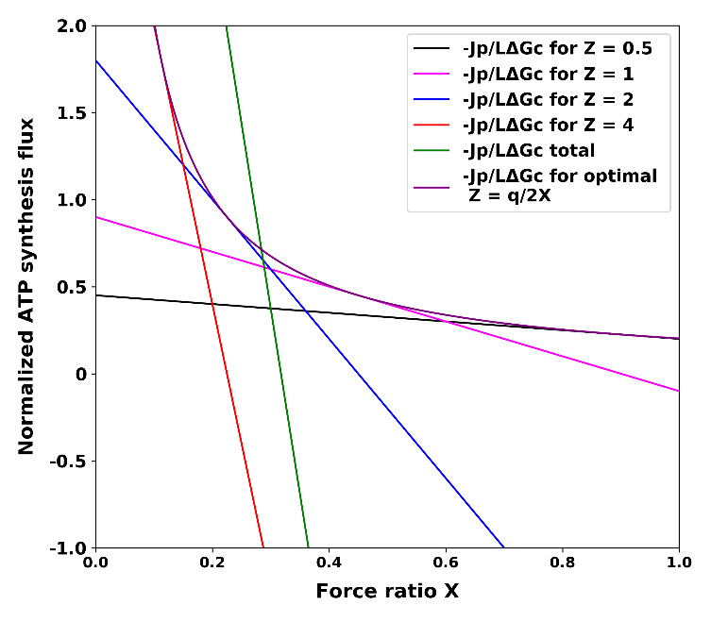

**Figure 2.** Variomatic and discontinuous optimal gear shifting. Normalized ATP synthesis flux versus force ratio at optimal but integer (full line) magnitudes of the phenomenological stoichiometry Z, and as optimal but continuously varying (‘variomatic’) magnitudes (purple line). See supplemental material S2 for details.

*3.3 Kinetic model demonstrating gear shifting in S. solfataricus*

In the preceding sections, we used a non-equilibrium thermodynamic description to illustrate the principles of gear shifting. This linear non-equilibrium thermodynamic description of bioenergetics is able to predict and describe the features of the process only qualitatively, as the linear flow force relations used are only strictly valid close to equilibrium. It should be more accurate to describe the effects of such gear shifting when using validated enzyme kinetic descriptions of the process, especially if these have been validated experimentally, at least in part. In this section we shall therefore implement a kinetic model to examine if one should expect gear shifting to occur given the known kinetic parameters and the known enzyme kinetics: this is the lower half of glycolysis in *S. solfataricus*.

The shift from the GAPDH route to the GAPN route at low ATP consumption flux by anabolism and maintenance, as produced by the FBA computation above, was caused by the FBA requirements that ATP should be at steady state and that ATP production should be maximal. Should fermentation persist in the GAPDH route, the amount of ATP produced would be higher than could be degraded by anabolism and maintenance, and steady state could then not be attained. Cell metabolism does not ‘know’ directly about any such formal requirements however, so what would be the mechanism for the steady state to remain? That mechanism should be the lack of the substrate ADP or the excess product ATP leading to product inhibition or reaction reversal and to the consequent reduction of the rate of the GAPDH reaction. In order to test this idea, we examined whether the gear shifting was also produced by a kinetic model based on experimentally determined parameter values that we previously built for this pathway (Zhang et al 2017).

Generally, there are two different ways to regulate metabolic fluxes. One is ‘hierarchical’ regulation by changes of gene expression that adjust enzyme capacities (Vmax) and the other is ‘metabolic’ regulation by changes in the interactions of enzymes with substrates, products, or allosteric effectors due to changes in concentrations of the metabolites (ter Kuile and & Westerhoff, 2001). Here the mathematical model of (Zhang et al., 2017) is used for demonstrating the ‘metabolic’ part of the regulation of the pathway flux towards maintaining steady state. As we did not have values for the kinetic parameters of a sufficient number of other reactions in the network, we simulated only the pathway from GAP to pyruvate (Figure 3A).

This simulation (Figure 3B and Figure 3C) shows that on the basis of the kinetic parameters known, the ATP/ADP ratio was indeed a determinant of the fluxes through the GAPDH plus PGK pathway and the GAPDH pathway. With the increase of the ATP/ADP ratio, the flux through GAPDH decreased, whilst the flux through GAPN increased monotonically. This embodies a homeostatic regulation of the fluxes that can maintain the steady state. It also corresponds to gear shifting, as the ratio of the two fluxes changes with changes in ‘work load’, i.e. with changes in the ATP/ADP ratio. From Figure 3B and Figure 3C we also note that at higher temperature (80 ℃) the fraction of GAPDH plus PGK pathway is more negative when compared with that at lower temperature (70 ℃), which means that the flux for GAPDH plus PGK in the gluconeogenesis direction is higher. We conclude that the ATP/ADP ratio could well be the force driving the shifting of the organisms from the high-gear GAPDH plus PGK route to the low-gear GAPN when the Gibbs energy becomes too high to allow flux through the former route. A complex feature here is that the former flux is always negative, i.e. runs in the gluconeogenic direction. Comparison of Figure 3B with Figure 3C shows that temperature changes can also cause gear shifting: a switch to lower gear at higher temperature. For comparisons with Figure 1 and Figure S2, Figure 3D also shows the variation of the flux-ratio stoichiometry *n* with the ATP flux. The stoichiometry increases with the flux, confirming the results of both the NET and the FBA analyses.



**Figure 3.** The scheme, fractions of the two pathway fluxes and the flux_ratio stoichiometry from GAP to 3PG. (**A**) Scheme of the pathways connecting GAP to pyruvate for *S. solfataricus*; lines with single arrow heads refer to reactions considered irreversible; the red dashed line refers to spontaneous (i.e. not enzyme catalyzed) hydrolysis of BPG to 3PG. (**B**) The fraction of the flux from GAP to Pyr running through GAPDH (blue; GAPN: organge) and the flux-ratio stoichiometry, all as functions of the ATP/ADP ratio, at 70 ℃. (**C**) The fraction of the flux from GADPH to Pyr flux running through GAPDH (blue; GAPN: orange) and the flux-ratio stoichiometry, all as functions of the ATP/ADP ratio, at 80 ℃. (**D)** The flux-ratio stoichiometry as function of the ATPase flux for the two different temperatures. The fluxes were computed using the kinetic model (Zhang et al., 2017) for various magnitudes of the rate constant for ATP hydrolysis and plotted versus the ATP/ADP ratio calculated. The Vmax’s in the rate law for the different reactions were changed according to Table 5 except for the Vmax for the ENO reaction (The Vmax for ENO reaction has not been measured, so we just kept value in the earlier model). In these models the concentrations of GAP, Pyr, NADP, NADPH, phosphate were fixed at 0.15, 1.85, 1.2, 0.39, and 10 mM, respectively. A negative fraction for the GAPDH flux reflects that this flux runs in the gluconeogenic direction (i.e. from 3PG to GAP). The models can be found in the Github repository under the folder name “Models” showed the simulations.

*3.4.* *Shifting between pathways during aerobic carbon and energy metabolism would lead to various ATP yields and thereby constitute gear shifting*

In supplementary S1 we reported that when oxygen is depleted there are 12 prospective fermentation pathways at various cost of ATP. Downstream of pyruvate there is the pyruvate dehydrogenase complex, the TCA cycle, and oxidative phosphorylation with NADH and succinate as reductants and molecular oxygen as oxidant.

Three terminal oxidases have been identified in *S. solfataricus*: SoxABCD, SoxEFGIM and DoxABCDE (Figure 4). The SoxABCD complex was proven to be a proton-pumping quinol oxidase in *S. acidocaldaricus* (Gleißner et al., 1997). The SoxABCD complex of *S. solfataricus* was described as a proton-pumping quinol oxidase because of its strong homology with the SoxABCD complex of *S. acidocaldaricus* (Lübben et al., 1994). The SoxABCD complex of *S. solfataricus* is composed of a subunit II (SoxA, sso2658), a cytochrome aa3 subunit I (SoxB, sso2657), a cytochrome b subunit (SoxC, sso2656), and an additional cytochrome b subunit (SoxD, sso10828) (Simon et al., 2009). This complex was found to combine features of respiratory complexes III and IV (Schäfer et al., 1999). In this complex the aa3 subunit (a product of the *soxB* gene) alone can function as a quinol oxidase (Anemüller et al., 1990). This SoxB represents a subunit I equivalent to the typical heme-Cu oxidase; its binuclear center contains two hemes A and one CuB. SoxA, like subunit II in the quinol oxidase of *E.coli*, lacks the typical mixed-valence binuclear CuA centre of cyt c oxidase. Another even larger complex which may also function as quinol oxidase is SoxEFGIM (which is further abbreviated as SoxM). In *S. acidocaldaricus* this complex combines features of quinol and cytochrome c oxidase (Komorowski et al., 2002). Since the SoxM complex of *S. solfataricus* has a strong homology to that in *S. acidocaldaricus*, it also thought to have these features. It is a complex of six subunits: sulfocyanin (SoxE, sso2972), Rieske iron-sulfur protein-2 (SoxF, sso2971), cytochrome b (SoxG, sso2970), subunit II (SoxH, sso2969), putative subunit (SoxI, sso2968) and subunit I/III, cytochrome aa3 (SoxM, sso2973) (Simon et al., 2009). This complex may represent a genetic as well as functional fusion of an analog to complex III with a ba3-type terminal oxidase utilizing sulfocyanine instead of cytochrome c (Schäfer et al., 1999). Apart from the SoxABCD complex and the SoxM complex, also the complex called DoxABCDE might function as quinol oxidase. Its homolog in another thermoacidophilic archaeon *Acidianus ambivalens* has been shown to have quinol oxidase activity (Müller et al., 2004).

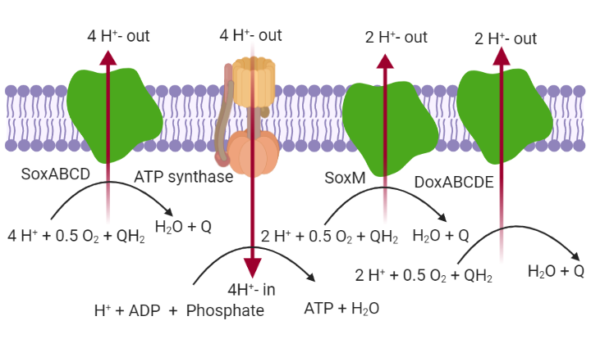

**Figure 4.** The different quinol oxidases in *S. solfataricus*, together with the H+-ATPase (ATP-synthase). This figure was created with BioRender.com. Sox stands for Sulfolobus oxidase, while Dox represents Dioxygen oxidase. H+-out, H+-in, QH2 and Q are written as H+_rc, H+, representative_quinol and representative_quinone, respectively, in the GEMM. SoxM is SoxEFGIM.

The three terminal oxidase complexes catalyze similar overall reactions. As the midpoint potential at electron entry differs between them (Schafer et al., 1999), there is a minor though important difference between the reactions they are reported to catalyze. For SoxM and DoxABCDE the reaction is “ 2 H+ + 0.5 O2 + representative quinol 🡪 2 H+rc + 2 Psi + H2O + representative quinone”, while for SoxABCD it is “4 H+ + 0.5 O2 + representative quinol 🡪 4 H+rc + 4 Psi + H2O + representative quinone”. Accordingly, the oxidases only differ in proton pump stoichiometry with corresponding implications for the ATP production they entail: they effect different gears of the system.

When allowing the import of oxygen and blocking the SoxABCD reaction, we found the flux pattern of Figure S4. Instead of employing PGAM and ENO to produce pyruvate, this flux pattern uses reactions of glycine, serine, and sulfopterin metabolism. We checked the RNA expression level of the proteins catalyzing these reactions in the supplementary file “80vs70 ArrayData”. We found that some of these proteins could not be expressed because too little of their mRNA was present. Consequently, in the subsequent simulation we blocked this flux pattern by blocking the reaction catalyzing the conversion of 10 – formyl-tetrahydrosulfopterin to formate.

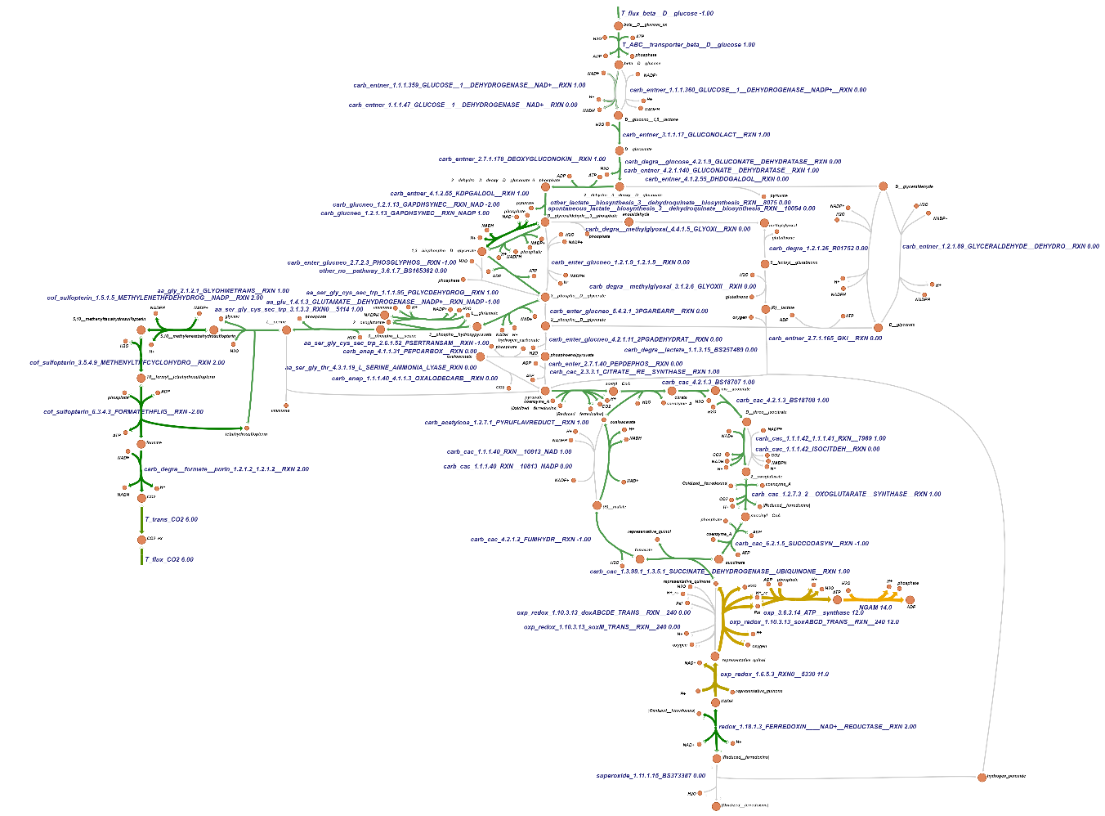

**Figure S4.** The flux pattern when allowing oxygen to be imported. Here, the upper bound of the glucose import reaction was fixed at 1 mmol gDW-1 h-1, all other bounds at 1000, and the NGAM maintenance reaction was used as the objective function when running the FBA. The file named “Simulation of shifting between pathways during aerobic carbon and energy metabolism with ATP synthesis as model output” found in the Github repository under the folder name “Codes” shows the simulation. Gray color corresponds to zero flux, while gradients of green, brown, and yellow correspond to non-zero flux, and from green to brown the flux increased.

Table 2 shows that when then different pathways interconverting 3-phosphoglycerate and pyruvate were allowed in combination with two different terminal oxidases (This was enforced in the FBA by blocking the other two terminal oxidases), the yield of ATP was diverse. Take the first pathway for example, the FBA showed that an ATP/glucose ratio of 14 was obtained when using the GAPDH and PGK pathway and then SoxABCD, as follows: (i) 2 ATP obtained at succinyl CoA synthetase, (ii) 6 NADH and 4 reduced ferredoxin pumping 40 protons (There is no classical complex I in the respiratory chains of Archaea (Schafer et al., 1996)); these should be leading to 10 ATP through the H+ATPase, (iii) through succinate dehydrogenase 2 representative quinols should be produced which could lead to the pumping of 8 protons, leading to 2 ATP. By using flux balance analysis, we find a diversity of 13 possible flux patterns with 8 different ATP yields.

**Table 2.** The ATP production flux when using different pathways. Maximum glucose uptake flux was taken to be 1 mmol gDW-1 h-1, while allowing the unlimited uptake of oxygen, phosphate, sulfate, ammonium, H+, H2O. The flux through the ATP hydrolysis reaction (growth rate independent maintenance; NGAM reaction) was used as the objective function when doing flux balance analysis and the flux through it (relative to the glucose influx) is reported, E.G. ‘6’ means 6 ATP per glucose. In all cases the glucose uptake flux reached its maximum. Pathway 1: from 3PG to Pyruvate, using phosphoglycerate mutase, enolase and pyruvate kinase catalyzed reactions. Pathway 2: from 3PG to Pyruvate, using phosphoglycerate mutase, enolase, PEP carboxylase and PEP synthase catalyzed reactions. This was obtained by blocking PK and 3-phosphoglycerate dehydrogenase reactions. Pathway 3: from 3PG to Pyruvate, using 3 phosphoglycerate dehydrogenase, phosphoserine phosphatase, phosphoserine aminotransferase and serine ammonia lyase catalyzed reactions. This was done by blocking PK and PEP carboxylase reactions.

|  |  |  |  |  |
| --- | --- | --- | --- | --- |
| Flux pattern number | From GAP to 3PG (see Fig S1) | From 3PG to Pyruvate | From Pyr to CO2  using SoxABCD | From Pyr to CO2 using SoxM (or DoxABCD) |
| 1 | GAPDH plus PGK pathway | Pathway 1 | 14 | 8 |
| 2 | Non-phosphorylation pathway | Pathway 1 | 13 | 7 |
| 3 | GAPDH and spontaneous degradation | Pathway 1 | 13 | 7 |
| 4 | GAPN pathway | Pathway 1 | 13 | 7 |
| 5 | Methylglyoxal pathway | Pathway 1 | 10 | 5 |
| 6 | GAPDH plus PGK pathway | Pathway 2 | 13 | 7 |
| 7 | Non-phosphorylation (GAPN) pathway | Pathway 2 | 12 | 6 |
| 8 | GAPDH and spontaneous degradation | Pathway 2 | 12 | 6 |
| 9 | GAPN pathway | Pathway 2 | 12 | 6 |
| 10 | GAPDH plus PGK pathway | Pathway 3 | 13 | 7 |
| 11 | Non-phosphorylation pathway | Pathway 3 | 12 | 6 |
| 12 | GAPDH and spontaneous degradation | Pathway 3 | 12 | 6 |
| 13 | GAPN pathway | Pathway 3 | 12 | 6 |

When we optimized for the production of biomass (The ATP maintenance (NGAM )flux was then fixed to 1.9 mmol ATP gDW-1h-1, because this value resulted in a carbon usage ratio of 25%, which has been determined in the laboratory (Ulas et al., 2012).), we observed that different pathways led to different biomass production fluxes (Table 3). This confirms that the biomass production has a strong connection with the energetics: If the pathway can produce more ATP energy, this may lead to higher biomass production.

**Table 3.** The biomass production fluxes of the various pathways. The fluxes start with maximum uptake flux of extracellular glucose at 1 mmol gDW-1 h-1 and with NGAM flux fixed to 1.9 mmol ATP gDW-1h-1, while allowing the unlimited uptake of oxygen, phosphate, sulfate, ammonium, H+, H2O. Biomass production reaction was used as the objective reaction in the flux balance analysis. The file named “Simulation of shifting between pathways during aerobic carbon and energy metabolism with biomass production as model output” found in the Github repository under the folder name “Codes” showed all the simulations.

|  |  |  |  |  |
| --- | --- | --- | --- | --- |
| Pathway numbers | Pathway names | From 3PG to Pyruvate | SoxABCD Biomas (h-1) | SoxM (or DoxABCD) Biomass (h-1) |
| 1 | GAPDH plus PGK pathway | Pathway 1 | 0.071 | 0.051 |
| 2 | Non-phosphorylation pathway | Pathway 1 | 0.066 | 0.043 |
| 3 | GAPDH and spontaneous degradation | Pathway 1 | 0.066 | 0.043 |
| 4 | GAPN pathway | Pathway 1 | 0.066 | 0.043 |
| 5 | Methylglyoxal pathway | Pathway 1 | 0.052 | 0.028 |
| 6 | GAPDH plus PGK pathway | Pathway 2 | 0.068 | 0.044 |
| 7 | Non-phosphorylation pathway | Pathway 2 | 0.062 | 0.036 |
| 8 | GAPDH and spontaneous degradation | Pathway 2 | 0.062 | 0.036 |
| 9 | GAPN pathway | Pathway 2 | 0.062 | 0.036 |
| 10 | GAPDH plus PGK pathway | Pathway 3 | 0.068 | 0.044 |
| 11 | Non-phosphorylation pathway | Pathway 3 | 0.062 | 0.036 |
| 12 | GAPDH and spontaneous degradation | Pathway 3 | 0.062 | 0.036 |
| 13 | GAPN pathway | Pathway 3 | 0.062 | 0.036 |

An intriguing question is why this organism has maintained both the SoxM complex and the DoxABCD complex in its evolutionary history, even though they catalyze the same reaction as SoxABCD does but at a lower gear setting. The use of SoxABCD should enable them to produce more ATP, which could then energize more growth. FBA optimizing for ATP or biomass can only give one, optimal, solution, which means that if the objective function is the production of ATP, FBA will not use the SoxM complex or the DoxABCD complex because using them will pump fewer protons that drive the production of ATP. Yet, both SoxM and DoxABCD are expressed in this organism (We verified this by analyzing the transcriptome; see the supplementary files with the name “80vs70 ArrayData”). Here we introduce a ‘Factor *z*’, which represents the gear setting required by anabolism. And we set the upper bound for the Sox M (DoxABCD) catalyzed reaction to 12-*z* (Here 12 is the maximum of SoxABCD flux in terms of 2-electron equivalents when glucose import is 1 (mmol gDW-1 h-1)) and the upper bound for the SoxABCD catalyzed reaction to *z*. For each value of *z* we then ran FBA with ATP production (i.e. flux through the maintenance reaction) as objective function. With this “Factor *z*” FBA did accommodate a shift between SoxABCD and SoxM (or DoxABCD) utilization, and with this shift, different amounts of the NGAM flux were obtained *in silico*. This led to Table 4, and a demonstration of the network’s potential to shift gears.

**Table 4.** ATP production as a function of the gear setting *z*. There are 13 possible gears, i.e. 13 possible settings for *z*. *z* is taken equal to 12 times the ratio of SoxABCD 2-electron flux to total 2 electron flux. Total flux is SoxABCD flux plus SoxM (or DoxABCD) flux. All calculations used the GAPDH-PGK- PK pathway between GAP and pyruvate. The fluxes start with maximum uptake of extracellular glucose at 1 mmol gDW-1 h-1, while allowing the unlimited uptake of oxygen, phosphate, sulfate, ammonium, H+, H2O.The ATP hydrolysis reaction (NGAM) was used as the objective function when doing flux balance analysis whilst setting the upper bound of the SoxABCD at various levels. The unit of this flux is mmol gDW-1 h-1. The file named “Simulation of shifting between pathways during aerobic carbon and energy metabolism with ATP synthesis as model outputchecking” found in the Github repository under the folder name “Codes” showed all the simulations.

|  |  |  |  |  |
| --- | --- | --- | --- | --- |
| Gear setting *z* | SoxABCD flux (in 2-electron equivalents per glucose import) | SoxM (DoxABCD) flux | NGAM (maintenance ATPase) | H+-ATPsynthase proton flux per glucose imported |
| 0 | 0 | 12 | 8 | 24 |
| 1 | 1 | 11 | 8.5 | 26 |
| 2 | 2 | 10 | 9 | 28 |
| 3 | 3 | 9 | 9.5 | 30 |
| 4 | 4 | 8 | 10 | 32 |
| 5 | 5 | 7 | 10.5 | 34 |
| 6 | 6 | 6 | 11 | 36 |
| 7 | 7 | 5 | 11.5 | 38 |
| 8 | 8 | 4 | 12 | 40 |
| 9 | 9 | 3 | 12.5 | 42 |
| 10 | 10 | 2 | 13 | 44 |
| 11 | 11 | 1 | 13.5 | 46 |
| 12 | 12 | 0 | 14 | 48 |

*3.5 Rewiring of metabolism*

*3.5.1 Gear shifting as inferred from transcriptome alterations*

By changing gene expression, organisms can rewire their metabolic map, i.e. repress some parts and express others. This may enable them to change the ATP yield of their metabolism, i.e. to shift gears. Temperature is an environmental factor that influences virtually all biological processes. Consequently, life at high temperature requires effective adaption strategies. In order to investigate temperature adaption strategies, the transcriptome of *S. solfataricus* has been measured by (Zaparty et al., 2009) during growth at two different temperatures (70 ℃ and 80 ℃).

By mapping partially the transcriptome data (shown in Table 5) to the reaction bounds if the model with the ‘αRNA🡪V factor’ (see Materials and Methods for an explanation of this factor; the simulations are shown in the Github repository in the file name “Mapping RAS to the bounds of the reactions” under the folder name “Codes”. ) fixed at 10-5 and the bound of the glucose exchange reaction fixed at 1 mmol gDW-1 h-1, the simulation results show that at low temperature (70 ℃) the organism uses the GAPDH-PGK pathway and the non-phosphorylation pathway (Figure S5), while at high temperature (80 ℃) the organism only uses the GAPDH and PGK pathway (Figure S6). Apart from this, there then is also a rewiring of terminal oxidases: at lower temperature the SoxABCD reaction carried more flux when compared with that at higher temperature. The maintenance ATPase flux (NGAM) predicted by the FBA was also lower at higher temperature. This suggests that perhaps the ATP production flux was limited due to the lower expression of the SoxABCD complexes at the higher temperature. The organism seems to shift to lower gears here by adjusting its gene expression. Enhanced flux through the other two terminal oxidases and through GAPDH plus PGK (at the cost of flux through the non-phosphorylative pathway through glycerate) may have been a consequence of the FBA attempting to re-increase its objective, the ATP production flux. Apparently the GAPDH and PGK expression levels were high enough to allow this to happen *in silico*. It should be stressed however that these FBA results only show flux potential, not the actual fluxes that would be obtained experimentally.

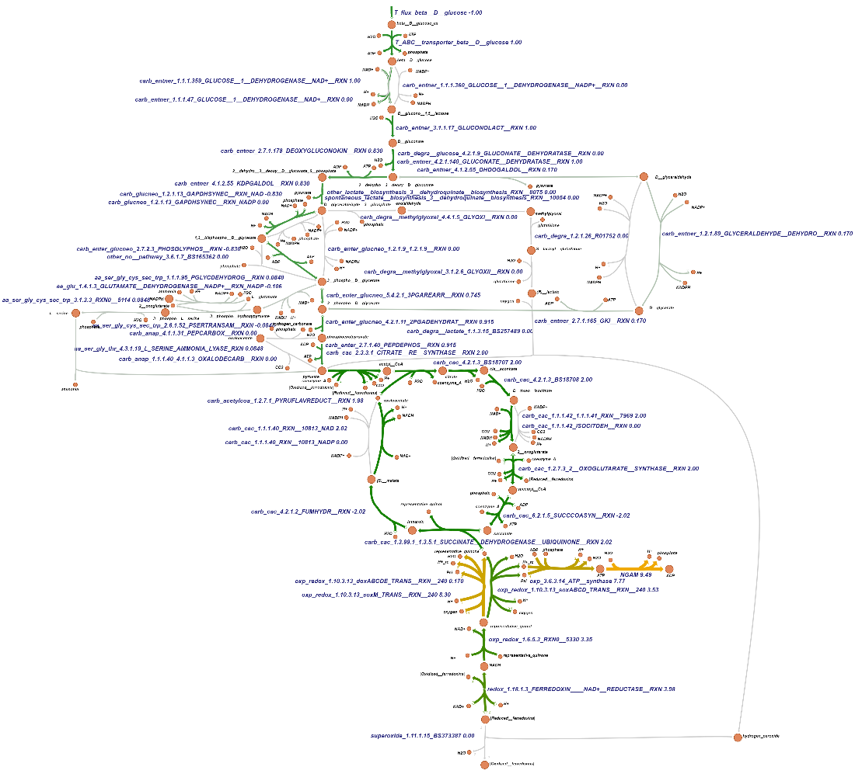

**Figure S5.** The flux distributionspredictedwhenmapping the transcriptomic data for the cells at lower (70° C) temperature to the genome wide metabolic map. Here the αmRNA🡪V factor was fixed at 10-5 and the bound of the glucose exchange reaction fixed at an inward flux of 1 mmol gDW-1 h-1. The NGAM (maintenance ATPase) reaction was used as the objective function for running FBA. Gray color corresponds to zero flux, while gradients of green, brown, and yellow correspond to non-zero flux, and from green to brown the flux increased.

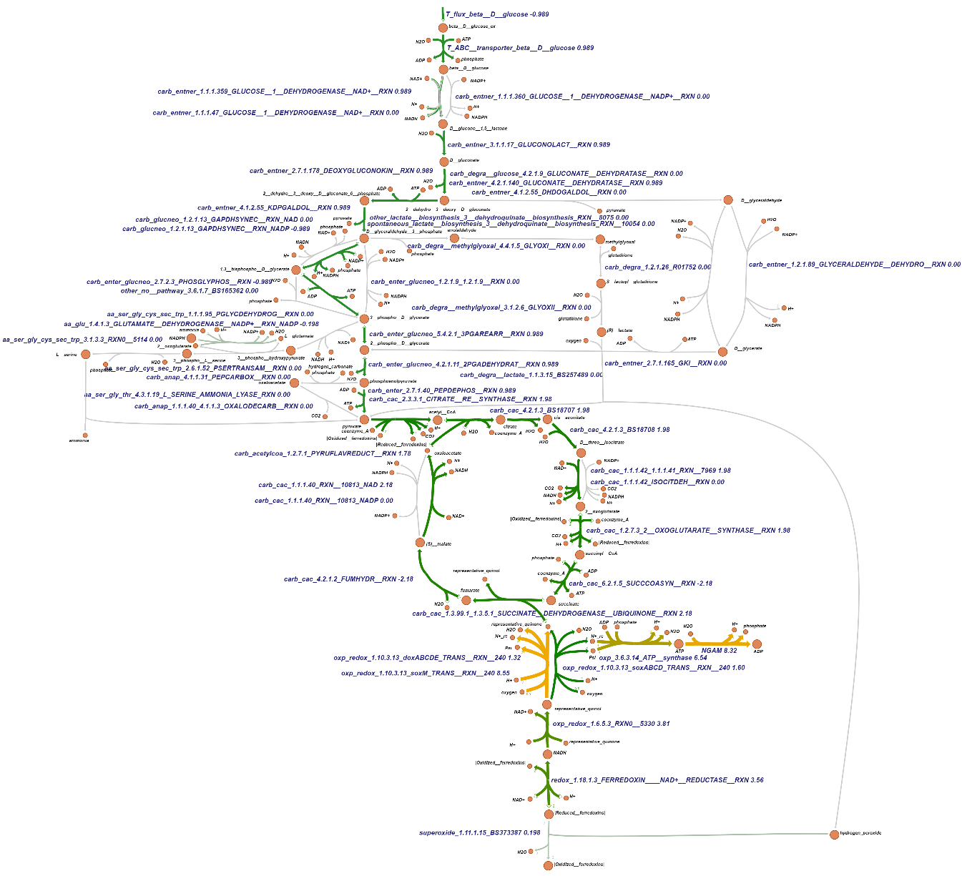

**Figure S6.** The flux distributionswhenmapping the transcriptomic data for the cells at higher temperature (80 °C) to the genome wide metabolic map. Here the α factor was fixed at 10-5 , the bound of the inward glucose exchange reaction being fixed at 1 mmol gDW-1 h-1. The NGAM reaction was used as the objective function when running the FBA. Gray color corresponds to zero flux, while gradients of green, brown, and yellow correspond to non-zero flux, and from green to brown the flux increased.

We also investigated whether this metabolic rewiring will happen when we vary the glucose exchange reaction bound under the condition of a fixed αmRNA🡪V factor. It turned out that at the high temperature, according to the FBA with maintenance flux as objective, the cell should always use GAPDH and PGK, also at different glucose availabilities (results not shown). At lower temperature if the glucose exchange reaction bound exceeded 0.745, the cell should use both the GAPDH-PGK pathway and the non-phosphorylation pathway, but should the bound be smaller than 0.745, the cell should only use the GAPDH-PGK pathway. Why should there be such a diversification of pathway fluxes when the glucose exchange reaction bound exceeds 0.745? We checked in our map and found that when the glucose exchange reaction bound exceeded 0.745, the flux through the PGAM reaction reached its upper bound which is 0.745. In order to use more glucose to provide more metabolic intermediates for the following reactions, the cell will then refer to the non-phosphorylation pathway which bypasses the PGM reaction.

We also investigated whether this metabolic rewiring will happen when we vary the αmRNA🡪V factor at a fixed glucose exchange reaction bound. It turned out that at high temperature, according to the FBA with maintenance flux as objective, the cell should always use GAPDH and PGK pathway when the αmRNA🡪V factor is larger than 1/74500, while both the GAPDH and PGK pathway and the non-phosphorylative pathway should be used when the αmRNA🡪V factor smaller than 1/74500. At the higher temperature there is no metabolic rewiring, even if a different αmRNA🡪V factor is used. All these results are shown in the Github repository in the file name “Mapping RAS to the bounds of the reactions” under the folder name “Codes”.

*3.5.2 Gear shifting as inferred from altered Vmax’s*

In the above simulations, we examined how the cells may have managed their FBA capabilities by adjusting the mRNA levels. It is always uncertain whether such adjustments perspire to the protein and Vmax level. Accurate proteomics and Vmax data are scarce however: in view of this lack of information on all the enzyme activities, we examined a smaller pathway (shown in Figure S7) between using the mRNA or using the Vmax of the enzymes as determined in the cell crude extract for setting the bounds of the reactions in FBA.

We used enzyme activities determined experimentally in crude extracts for some of the enzymes (Table 5) as the upper bounds for the corresponding reactions. We had no data on the Vmax of the glucose transporter however, as this cannot be determined in the cell free extract. As the upper bound of the glucose import reaction was fixed at 1 mmol gDW-1 h-1, before equating the enzyme activities data with the upper reaction bounds, we multiplyed the values by a crude-extract-activity-to-Vmax factor, which we called αcea🡪V. After multiplying by this factor, most of the bounds of the reactions were in the same order of magnitude as the glucose import reaction, if this factor was taken equal to 0.01. When we thereby used the enzymes activities of the cell crude extract growing at lower temperature (70 ℃) as the bounds for the reactions, we saw a shifting between the GAPDH-PGK pathway and the GAPN pathway. This shifting depended on the bound set for the glucose import: when the flux of the glucose import reaction exceeded 0.3, the shifting among these two pathways appeared. The reason for this shifting was that the upper bound of the PGK reaction is 0.3. Consequently, when the bound of glucose importing reaction exceeds 0.3, in order to produce more pyruvate, the map will resort to the GAPN pathway to bypass the PGK capacity ceiling and produce more 3PG. All the simulations are shown in the file named “mapping Vmax to the small pathway” under the folder name “Codes” in the Github repository.

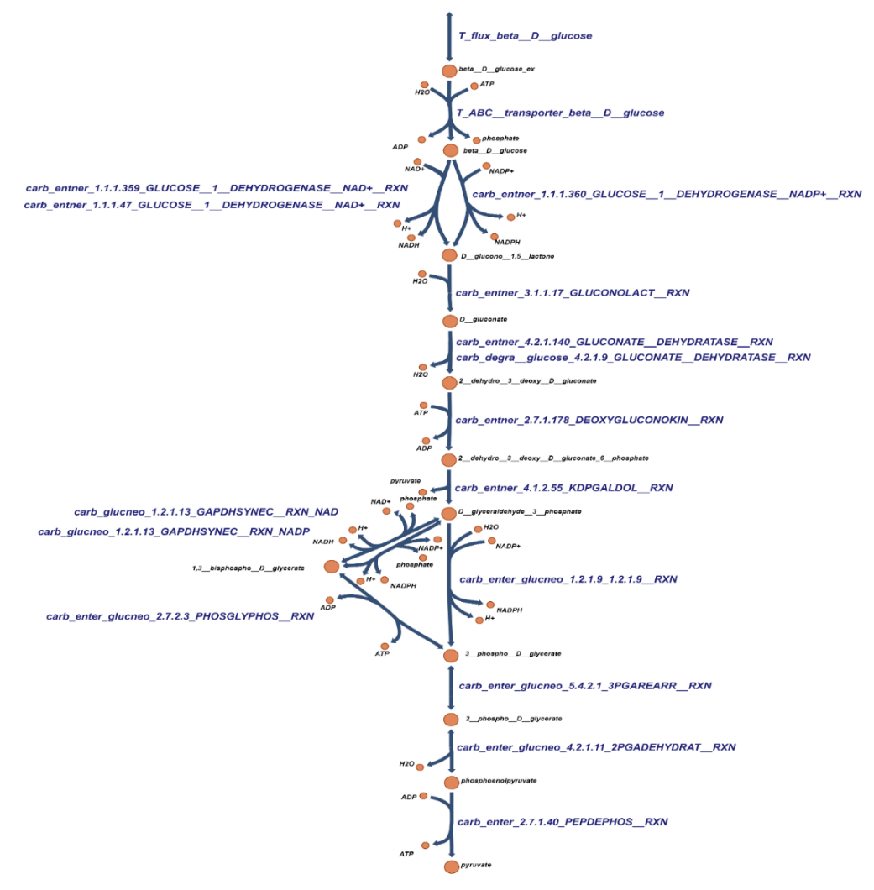

**Figure S7.** The reduced set of pathways used for investigating the difference between mRNA and maximum enzyme activities after mapping them to the genome-wide metabolic map.

**Table 5.** Enzyme activities of pathways of Figure S7 in the cells’ crude extract and absolute values of mRNA encoding the enzymes.

|  |  |  |  |  |  |
| --- | --- | --- | --- | --- | --- |
| Reaction id | Enzyme name | Enzyme activities in cell crude extract (µmol min-1 gCE-1) | | mRNA (80 ℃) | mRNA (70 ℃) |
| 80 ℃ | 70 ℃ |  |  |
| T_ABC__transporter_beta__D__glucose | ABC transport | ----- ¹ | ----- | 184457 | 101448 |
| carb_entner_1.1.1.359_GLUCOSE__1__DEHYDROGENASE__NAD+__RXN | GDH **²** | 1170 | 270 | 131251 | 116348 |
| carb_entner_1.1.1.47_GLUCOSE__1__DEHYDROGENASE__NAD+__RXN | GDH **²** | 1170 | 270 | 131251 | 116348 |
| carb_entner_1.1.1.360_GLUCOSE__1__DEHYDROGENASE__NADP+__RXN | GDH **²** | 250 | 96 | 131251 | 116348 |
| carb_entner_3.1.1.17_GLUCONOLACT__RXN | GL | ----- | ----- | 1000000 ⁵ | 1000000 |
| carb_entner_4.2.1.140_GLUCONATE__DEHYDRATASE__RXN | GAD ³ | 170 | 92 | 836571.5 | 356251 |
| carb_degra__glucose_4.2.1.9_GLUCONATE__DEHYDRATASE__RXN | GAD **³** | 170 | 92 | 836571.5 | 356251 |
| carb_entner_2.7.1.178_DEOXYGLUCONOKIN__RXN | KDGK **³** | ----- | ---- | 291272.8 | 253355.8 |
| carb_entner_4.1.2.55_KDPGALDOL__RXN | KDPGA **³** | 120 | 55 | 597318.7 | 346968 |
| carb_glucneo_1.2.1.13_GAPDHSYNEC__RXN_NAD | GAPDH **³** | 87 | 43 | 653018.3 | 675898.5 |
| carb_glucneo_1.2.1.13_GAPDHSYNEC__RXN_NADP | GAPDH **³** | 87 | 43 | 653018.3 | 675898.5 |
| carb_enter_glucneo_2.7.2.3_PHOSGLYPHOS__RXN | PGK **²** | 110 | 30 | 599572.8 | 492960.8 |
| carb_enter_glucneo_1.2.1.9_1.2.1.9__RXN | GAPN **³** | 36 | 21 | 648866.8 | 295347 |
| carb_enter_glucneo_5.4.2.1_3PGAREARR__RXN | PGM **²** | 75 | 93 | 74533 | 100476.5 |
| carb_enter_glucneo_4.2.1.11_2PGADEHYDRAT__RXN | ENO **³** | ----- | ---- | 410775.3 | 425307.3 |
| carb_enter_2.7.1.40_PEPDEPHOS__RXN | PK **²** | 76 ⁴ | 70 | 192121 | 307618 |

¹ The symbol “ ---- “ means that the activities of these enzymes have not been measured.

**²** Enzyme activities measured by Haferkamp (Haferkamp, 2011).

**³** Enzyme activities measured by Kouril (Kouril, 2012).

⁴Due to heat instability of PEP, the PK activity could only be determined at 70 °C, so here the number is the enzyme activity measured at 70 °C in crude extract of cells growing at 80 °C.

⁵ This reaction happens spontaneously, so we just used a high number for this reaction.

The file named “reaction_id_RAS” shown in the Github repository under the folder name “data” shows that the RNA level of GAPN at lower temperature (648866) is around twice that at high temperature (295347; see also Table 5). One might expect this to lead to a reduced GAPN flux at high temperature. The same applies to the Vmax levels. However, in the flux balance analysis described above for the mRNA results we did not see any predicted use of GAPN at all. This was caused by the fact that the RNA level of the PGAM is limiting. When mapping two different datasets (mRNA and enzyme activities) to the bounds of the reactions, we obtained different results. This may be caused by the fact that the genome wide metabolic map does not consider the regulation of the enzyme Vmax’s such as through inhibitory post translational modifications.

In order to check this, we referred to the kinetic models which contain the pathway from GAP to pyruvate (Figure 3A) (Zhang et al., 2017). These models had been built based on the kinetic parameters measured *in vitro*. For the present study we replaced the enzyme Vmax for different reactions in the published model with the corresponding specific activity measured in the crude extract of the cell growing at 80 ℃ which was also measured at 80 ℃ *in vitro* by Kouril. The Vmax‘s for the crude extract of the cell growing at 70 ℃ as measured at 70 ℃, were used for comparison with those at 80 ℃ (Kouril, 2012). The computed fluxes through GAPDH, PGK and GAPN are shown in Table 6. From Table 6, we infer that for this small pathway the overall flux from GAP to pyruvate is higher at high temperature than at low temperature, which is in good agreement with the fact that *S. solfataricus* grows optimally at 80 ℃ (Kouri, 2012). Apart from this difference in the overall flux between these two temperatures, there is also a large difference in the fluxes through GAPDH and PGK and GAPN. At low temperature the fluxes through GAPDH and PGK, which run in the in the gluconeogenic direction, were only 0.12 mM/min, while at the high temperature they are more than 70 times higher.

**Table 6**. Modelled fluxes (mM/min) at steady state for *S. solfataricus*. Pathways are shown in Figure 3A.

|  |  |  |
| --- | --- | --- |
| **Cells‘ growth temperature / enzyme activity measuring temperature** | **80 °C / 80 °C** ¹ | **70 °C / 70 °C ²** |
| Overall flux | 20.5 | 17.1 |
| JGAPDH | -9.1 | -0.12 |
| JPGK | -9.1 | -0.12 |
| JGAPN | 29.5 | 17.2 |
| JPGAM | 20.5 | 17.1 |
| JENO | 20.53 | 17.13 |
| JPYK | 20.54 | 17.1 |

¹ Here we used the enzyme activity of the crude extract of the cells growing at 80 ℃ and measured at 80 ℃. 3As the enzyme activity of ENO has not been measured, we just used the value in the published model.

4**. Discussion**

Many living organisms have a high ability to adapt to changes in their environment, such as changes of temperature, partial oxygen pressure, or substrate concentrations. The changes in the environment affect transporters, receptors and/or intracellular enzymes (Temperature) and the organisms then respond by metabolic or gene expression regulation (Ter Kuile and Westerhoff, 2001) of enzyme activities. Possibly the simplest case is that of running some more (or less) flux through all of the existing pathways. This happens when only the growth rate is adapted to an environmental change such as a minor reduction in the concentration of the growth substrate, leading to a proportional change in growth rate. This situation obtains in a chemostat when the dilution rate is reduced slightly or in an ecosystem where substrate concentrations may vary somewhat. It is however not the type of condition that is often studied in laboratories. There more often the environmental challenge is qualitative, e.g. consists of the substitution of one type of growth substrate for another. The organism may then adapt fluxes by redirecting flux through pre-expressed pathways and by expressing more of the newly required pathway and less of the preexisting ones. We shall call this ‘metabolic switching’. It consists of the amplification or inactivation of entire pathways, without changing their quality or function.

In this paper we addressed a third type of adaptation, which occurs when there is a trade-off between two tasks of a single metabolic network, such as the provision of both Carbon building blocks and Gibbs energy to anabolism.

The thermodynamic driving force for growth () may be compromised in magnitude if one of the growth substrates becomes limiting in concentration. For thermophiles like *S. solfataricus* this could be the oxygen required for aerobic growth, as the tendency of oxygen to dissolve in water decreases by a factor of 4 between 25 C and 80 C. For aerobic processes the drop in Gibbs energy between catabolic substrates and catabolic products often comes with a large drop in enthalpy. This implies a strong reduction of that Gibbs energy with increasing absolute temperature, which is notable across GAPDH + PGK (Zhang et al., 2017). And whilst acidophiles keep most of their enzymes safe at their intracellular pH, which is only slightly lower than 7 (She et al., 2001), parts of their transporters are facing the extracellular medium at a pH below 4, and may thereby denature, making substrate uptake and thereby the intracellular substrate concentrations, limiting factors. One should therefore consider the relevance of changes in flux stoichiometries (‘Z’, ‘z’ or ‘*n*’, which all have a slightly different meaning, as shown above) for when ∆Gc is small relative to ∆Ga.

One reason for this is that the stoichiometries can change readily provided that we do not limit the system to a single enzyme-catalyzed reaction but consider a metabolic network. In order to estimate the extent of this variation of the phenomenological stoichiometry *Z*, we used the non-equilibrium thermodynamic description mentioned above, but now for two parallel pathways driven by the same catabolic Gibbs energy drop and working against the same potential, . For two parallel pathways with ATP stoichiometries of *n1* and *n2,* we found that one should expect this stoichiometry to vary with the thermodynamic driving forces at play. This may have been a bit unexpected because in previous non equilibrium thermodynamic analyses, the ‘phenomenological stoichiometry’ Z was always treated as a constant, whilst the force ratio (/) or the degree of coupling q were considered to be adjustable or variable (Kedem and Caplan, 1965; Stucki, 1980).

We also found that for every thermodynamic setting in terms of (/) a different value of the stoichiometry should be optimal for maximal synthesis of ATP and thereby growth rate. This also has implications for the optimum thermodynamic efficiency. For the optimum state that we identified above, the thermodynamic efficiency is smaller than 50%, for:

and q < 1. Microbial growth is highly inefficient thermodynamically (Westerhoff et al., 1983) and perhaps this is part of the explanation; a part that is different from the explanation given in ( Westerhoff et al., 1983).

Our findings make this particularly understandable for the catabolic segment connecting GAP with 3-PGA. When anabolism is limited because of lack of *anabolic* substrate, the Gibbs energy of ATP hydrolysis will increase with increasing limitation. In our kinetic model we found that the flux between GAP and 3 PGA through GAPDH and PGK may then invert, thereby making catabolism of glucose through this route impossible. The cell then needs to switch to one of the other routes with a lower ATP/ glucose ratio, such as the route through GAPN. This simulation also evidenced that in order to effect the shift to a lower stoichiometry Z no gene expression regulation should be needed; the usual kinetics of the system together with changes in metabolite concentrations should already cause this gear shifting.

The situation of these organisms may then be similar to that of an automobile driving uphill, with the slope of the hill replacing , and with (minus) the Gibbs energy of combustion of the gasoline. With the slope of the hill becoming steeper, the velocity of the car in any given gear setting will decrease and at some point it will be better to switch to lower gear in order to maintain speed. There will be fewer turns of the car’s wheels for a given number of strokes of its pistons, but the piston strokes occur at a higher frequency than they would have done at the original, higher, gear setting. On a horizontal motorway the better state is the highest gear setting. It is for this analogy that we speak of the metabolic switch to a pathway with a different ATP-to-substrate ratio, as ‘gear shifting’.

Although switching to lower gear may increase the growth rate, it most often decreases both the growth yield and the thermodynamic efficiency of growth. Gear switching comes with a trade-off between growth rate on the one hand and growth yield and efficiency on the other. MacArthur and Wilson (1967) already addressed such a trade-off in their r/k-selection theory. r-selected species engage in high growth rates but with low probability of surviving to adulthood. K-selection species invest in sturdiness more than growth rate. The latter are typically strong competitors with almost every individual surviving to adulthood. Westerhoff et al (1983) calculated thermodynamic efficiencies of microbial growth and found that these were low. For substrates more oxidized than biomass the efficiencies were close to 20 %, the value predicted by Westerhoff et al. (1983) for maximal growth rate at optimal efficiency, i.e. the result consistent with an optimal trade-off between growth rate and efficiency. Microorganisms always maintained under balanced growth conditions such as in turbidostat, should be expected to have become selected for maximum growth rate, but for growth in repeated batch conditions with starvation periods in between, such as in isolated drops of substrate (and in the practice of how microbial strains are maintained in the laboratory), selection for efficiency should contribute more to the survival of the organism than selection for growth rate (Westerhoff and Van Dam, 1987). The latter growth condition has since been used for the selection of strains with enhanced productivity (Tatenhove-pel et al., 2020).

Whether there is r-selection such as apparently in our example of *S. solfataricus* (Figure 1) rather than k-selection should depend on the environment. Less-crowded environments should favor r-selection while in crowded places with the densities of a species close to the environment’s carrying capacity, k-selection should prevail (Pianka et al., 1972). This translates to a more crowded environment leading to substrate limitation hence a decreased and an increased and hence a decrease in optimal Z. A case in point should be oxygen limitation due to a crowded environment or a high temperature. Considering the alternative quinol oxidases soxABCD and soxM of *S. solfataricus* at low pO2, one should expect r-selection to favor soxM (or soxABCDE, both of which only pump two protons per pair of electrons) over soxABCD (which pumps 4 protons per two electrons). Yield (k-) selection should route the flux towards soxABCD.

In *S. solfataricus* at low-O2 conditions, the gene cluster of soxABCD is overexpressed, while under high-O2 conditions the expression of SoxM is upregulated (Simon et al., 2009): Through gene expression Z here increases with oxygen limitation, i.e. as increases, whereas through metabolic regulation Z should have decreased. Remarkably perhaps, the gene expression regulation is here consistent with k (yield) selection at low oxygen concentrations rather than to favor a fast synthesis of ATP and fast growth. The organism may prefer to grow at a higher yield, i.e. to have, per oxygen molecule available more ATP synthesized.

There are no data for the affinity of oxygen for SoxABCD and SoxM for *S. solfataricus*, but for *Aeropyrum pernix* K1, which is quite close to *S. solfataricus*, it has been reported that SoxM has a lower affinity for O2 than SoxABCD (Ishikawa et al., 2002), i.e. a KMO2 of 5 µM for SoxABCD and 32 µM for SoxM. We propose to use the term ‘gear shifting’ for cases where the organism alters the effective stoichiometry at which it makes ATP, for the purpose of its fitness, independent of whether this is a reduction or an increase in the stoichiometry.

In Biology one also finds a functionally similar yet biochemically different phenomenon: a switch to a different catabolic process with a concomitant change in the number of ATP’s delivered per substrate molecule catabolized. If the concentration of the growth substrate becomes lower, yeast cells for instance shift to respiration from fermentation with a concomitant reduction in growth rate (Van Hoek et al., 1998; Chumnanpuen et al., 2014; de Jong et al., 2014). This is not gear shifting *per se,* as the catabolic reaction changes, with CO2 only, rather than ethanol plus CO2, as catabolic products from glucose. The catabolic Gibbs energy used per molecule of ATP hardly changes (a 15 % reduction [from 100 to 85 kJ/mol ATP] for a 15 fold increase in catabolic Gibbs energy). More similar to gear shifting is the case where the addition of the uncoupler benzoic acid to yeast enhanced the flux through glycolytic enzymes by a factor of 10 (Daran-lapujade et al., 2007); one could construe this as a reduction in ATP stoichiometry of catabolism and hence as gear shifting.

In *E.coli* at high glucose consumption, acetate is formed. The expression of NADH oxidase can then help alleviate the repression of many genes involved in the tricarboxylic acid (TCA) cycle, reduce acetate production, and increase biomass production (Vemuri et al., 2006). Under glucose limitation *L. lactis* changes from homolactic to heterolactic fermentation and this can be stimulated by overexpression of NADH oxidase (Hoefnagel et al., 2002). Both these cases are again examples of catabolic rewiring rather thanjust a change in ATP stoichiometries: although still heterolactic fermentation one more ATP is produced per glucose, as acetate plus formate plus ethanol are produced instead of just lactate.

With respect to explanations for gear shifting and catabolic switching, we may distinguish between the mechanistic and the teleological explanations. In terms of the former (Daran-lapujade et al., 2007) showed that metabolic regulation often plays an important role, in addition to some gene expression regulation taking place resulting in metabolic rewiring. Through such rewiring tumor cells may switch to glutamine catabolism for instance (Damiani et al., 2017; Damiani et al., 2019). The mechanism behind mixed acid fermentation involves changes in the concentrations of both fructose 1,6 bisphosphate and lactate dehydrogenase (Thomas et al., 1979), i.e. again both metabolic and gene expression regulation. Metabolic regulation as the basis for gear shifting could be advantageous because it is fast. This could be useful for *S. solfataricus* in hot springs where it may be subject to strong variations in temperature and oxygen tension over short periods of time. Adaptation to steady extreme conditions is understood for various organisms, but adaptation to rapid variability in conditions is another matter. The present paper may constitute an entry point.

An example of how catabolic switching may contribute to fitness is found in yeast: when glucose is sufficient, *Saccharomyces* will first accumulate ethanol no matter oxygen is there or not. The accumulated ethanol can then inhibit the growth of competing organisms, or can be used as a substrate when the glucose concentration is lower (Merico et al., 2007). *L. lactis* can excrete an extracellular protease to degrade milk proteins into freely utilizable peptides when the peptides in the environment are insufficient for the cells to grow. Not all the cells do this, as the protease will function outside of the cell and the peptide produced can also be used by neighboring cells (Bachmann et al., 2011). A similar phenomenon exists in yeast. When there is not enough substrate like glucose or fructose, some cells will start to produce invertase, which can catalyze the breakdown of sucrose. Other yeast cells (which are called ‘cheater’) do not produce this invertase. They just use the glucose or fructose degraded from sucrose by the invertase produced by yeast cells that are close by (Gore et al., 2009). In this condition, the signal is the substrate level and the yeast cells will switch between producing invertase and not producing invertase. The fitness function of gear shifting *sensu stricto* cannot be inferred from these examples, as they do involve changes in metabolism other than ATP yield. The function of gear shifting may be limited to an enhanced growth rate under energetically challenging circumstances or to overflow metabolism to reduce ATP levels in cases of energy affluence.

Knowing the potential of gear shifting is one thing but proving that it actually occurs is another. The most accurate and efficient way is to measure the flux of different pathways of the cells which are growing in chemostat. With perturbations, the flux among different pathways may change and the gear shifting might show. The fluxes through the pathways can be measured by using isotope- labeled substrate, and this method can show the gear shift directly (The isotope was not present in a pathway and then it was) and allows the dimension of time to be introduced. However, the shortcoming of this method to measure the gear shift is that it can only be used to measure gear shifting with pathways using the isotope-labeled substrate. Another way to measure gear shifting is to measure growth yields. In chemostats growth yields have been shown to increase with the dilution rate and hence with the concentration of the growth limiting substrate. This has mostly been attributed to growth rate independent maintenance metabolism becoming less important quantitatively. As the resulting yields did not match the yields expected theoretically (Stouthamer et al., 1987; Westerhoff et al., 1987) it has been proposed that there could also be growth rate dependent maintenance (Neijssel and Tempest, 1976). Westerhoff et al (1982) showed that this could be a consequence of the same mechanism of incomplete coupling between catabolism and anabolism that sits behind the growth rate independent maintenance (Westerhoff et al., 1982). Here we note that the decrease in growth yield with decreasing chemostat dilution rate could also be caused by gear shifting to lower catabolic stoichiometries.

If the regulation of gear shifting occurs through alterations in gene expression, one may measure transcript or protein levels using deep sequencing and mass spectrometry, respectively. This method has some advantages such as high throughput and capacity for automation. However, this method is based on the hypothesis that the mRNA or protein levels can represent the flux through the corresponding pathways; it does not address gear shifting through metabolic regulation (ter Kuile and Westerhoff, 2001).

The genome-wide metabolic map is useful because it includes the total metabolic potential and thereby part of the thermodynamic potential that an organism has available. For *S. solfataricus* there is no positive gear setting for the catabolism between glucose and pyruvate, i.e. there is no pathway in the GEMM between these two molecules that has a positive ATP yield. This of course depends on the glucose uptake system of the GEMM of *S. solfataricus* being an ATP dependent system rather than a proton or sodium symport or a glucose uniport such as in other organisms. It also depends on the fact that in this modified pathway in the reactions catalyzed by 2-dehydro-3-deoxy-phosphogluconate aldolase or 2-keto-3-deoxygluconate aldolase one product is pyruvate: the production of this pyruvate does not produce any ATP, while through the normal GAPDH - PGK pathway 2 molecules of ATP should have been produced. Another reason is that the export of lactic acid becomes thermodynamically infeasible, as we have shown in supplementary S4.

We conclude that gear shifting is a feasible option for extremophiles to head off thermodynamic threats. Whether it serves mesophiles equally well, remains to be seen.

**Acknowledgments:**

Yanfei Zhang thanks the China Scholarship Council for a PhD fellowship. The authors acknowledge Theresa Kouril who helped in the preparaton of the manuscript. The authors thanks to collaborator Dr Pawel Sierocinski in the group of J. van der Oost of the Wageningen University for supplying the transcriptomic data of the two biological samples (the cells growing at 70 and 80 ℃).

**Conflicts of Interest:** The authors declare that there is no conflict of interest.

**References**

Anemüller, S., and Schäfer, G. (1990). Cytochrome aa3 from Sulfolobus acidocaldarius. *Eur. J. Biochem.* 305, 297–305. doi: 10.1111/j.1432-1033.1990.tb19123.x

Bachmann, H., Molenaar, D., and Kleerebezem, M. (2011). High local substrate availability stabilizes a cooperative trait. *The ISME J*. 5(5): 929–932. doi: 10.1038/ismej.2010.179

Woese, C. R., Kindler, O., and Wheelis, M. L. (1990). Towards a natural system of organisms: proposal for the domains Archaea, Bacteria, and Eucarya. *Proc. Natl. Acad. Sci.* U S A 87, 4576–4579. [doi: 10.1136/bmj.1.4540.46](https://doi.org/10.1136/bmj.1.4540.46)

and *Int. J. Genomics*. 2014, 894296. doi:

Damiani, C., Colombo, R., Gaglio, D., Mastroianni, F., Pescini, D., Westerhoff, H. V., Mauri, G., Vanoni, M., and Alberghina, L. (2017). A metabolic core model elucidates how enhanced utilization of glucose and glutamine , with enhanced glutamine- dependent lactate production , promotes cancer cell growth : The WarburQ effect. *PLoS Comput. Biol.* 13(9):e1005758. doi: 10.1371/journal.pcbi.1005758

Damiani, C., Maspero, D., Filippo, M. Di, Colombo, R., Pescini, D., Graudenzi, A., et al. (2019). Integration of single-cell RNA-seq data into population models to characterize cancer metabolism. *PLoS Comput. Biol.* 1–25. doi: 10.1371/journal.pcbi.1006733

Daran-lapujade, P., Rossell, S., Gulik, W. M. Van, Luttik, M. A. H., Groot, M. J. L. De, Slijper, M., et al. (2007). The fluxes through glycolytic enzymes in Saccharomyces cerevisiae are predominantly regulated at posttranscriptional levels. *Proc Natl Acad Sci U S A.* 104(40): 15753–15758. doi: 10.1073/pnas.0707476104

de Jong, B. W., Shi, S., Siewers, V., and Nielsen, J. (2014). Improved production of fatty acid ethyl esters in Saccharomyces cerevisiae through up-regulation of the ethanol degradation pathway and expression of the heterologous phosphoketolase pathway. *Microb. Cell Factories*. 13(1), 1–10. doi: 10.1186/1475-2859-13-39

Ebrahim, A., Lerman, J. A., Palsson, B. O., and Hyduke, D. R. (2013). COBRApy: COnstraints-Based Reconstruction and Analysis for Python. *BMC Syst. Biol*. 7: 74. doi: 10.1186/1752-0509-7-74

Elferink, M. G. L., Albers, S. V., Konings, W. N., and Driessen, A. J. M. (2001). Sugar transport in Sulfolobus solfataricus is mediated by two families of binding protein-dependent ABC transporters. *Mol. Microbiol.* 39(6), 1494–1503. doi: 10.1046/j.1365-2958.2001.02336.x

Gasmi, N., Jacques, P. E., Klimova, N., Guo, X., Ricciardi, A., Robert, F., and Turcotte, B. (2014). The switch from fermentation to respiration in Saccharomyces cerevisiae is regulated by the Ert1 transcriptional activator/repressor. *Genetics* 198(2), 547–560. doi: 10.1534/genetics.114.168609

Gleißner, M., Kaiser, U., and Antonopoulos, E. (1997). The Archaeal SoxABCD Complex Is a Proton Pump in Sulfolobus acidocaldarius. *J. Biol. Chem* 272(13), 8417–8426. doi: 10.1074/jbc.272.13.8417

Gore, J., Youk, H., & Oudenaarden, A. Van. (2009). Snowdrift game dynamics and facultative cheating in yeast. *Nature*, *459*, 253–256. doi: 10.1038/nature07921

Haferkamp, P. (2011) Biochemical studies of enzymes involved in glycolysis of the thermoacidophilic crenarchaeon Sulfolobus solfataricus. [PhD’s thesis]. [Essen]: University Duisburg-Essen

Van et al. *Microbiology* 148: doi: 10.1099/00221287-148-4-1003

Ishikawa, R., Ishido, Y., Tachikawa, A., Kawasaki, H., Matsuzawa, H., and Wakagi, T. (2002). Aeropyrum pernix K1, a strictly aerobic and hyperthermophilic archaeon, has two terminal oxidases, cytochrome ba3 and cytochrome aa3. *Archives of Microbiology* 179(1), 42–49. [doi: 10.1007/s00203-002-0496-1](https://doi.org/10.1007/s00203-002-0496-1)

and

King, Z. A., Dräger, A., Ebrahim, A., Sonnenschein, N., Lewis, N. E., and Palsson, B. O. (2015). Escher: A Web Application for Building, Sharing, and Embedding Data-Rich Visualizations of Biological Pathways. *PLoS Comput. Biol.* 11(8), 1–13. doi: 10.1371/journal.pcbi.1004321

Komorowski, L., Verheyen, W., and Schaefer, G. (2002). The archaeal respiratory supercomplex SoxM from S. acidocaldarius combines features of quinole and cytochrome c oxidases. Biol. Chem. 383(11):1791-1799. doi: 10.1515/BC.2002.200

Koning, S. M., Albers, S. V., Konings, W. N., and Driessen, A. J. M. (2002). Sugar transport in (hyper)thermophilic archaea. *Research in Microbiology*. 153(2), 61–67. doi: 10.1016/S0923-2508(01)01289-X

[PhD’s thesis]. [Amsterdam]: Vrije Universiteit Amsterdam

Lübben, M., Warne, A., Albracht, S. P. J., and Saraste, M. (1994). The purified SoxABCD quinol oxidase complex of Sulfolobus acidocaldarius contains a novel haem. *Mol. Microbiol.* 13(2), 327–335. doi: 10.1111/j.1365-2958.1994.tb00426.x

Wilson, E.O. and MacArthur, R.H., 1967. The theory of island biogeography (Vol. 1). Princeton, NJ: Princeton University Press.

and*.* doi:

Mondeel, T. D. G. A., Rehman, S., Zhang, Y., Verma, M., Durre, P., Barberis, M., and Westerhoff, H. V. (2016). ScienceDirect Maps for when the living gets tough : Maneuvering through a hostile energy Maps for when the living gets tough : Maneuvering through a hostile energy Maps landscape. *IFAC PapersOnLine* 49(26), 364–370. doi: 10.1016/j.ifacol.2017.03.002

Molenaar, D., Van Berlo, R., De Ridder, D., and Teusink, B. (2009). Shifts in growth strategies reflect tradeoffs in cellular economics. *Mol. Syst. Biol.* 5(323), 1–10. doi: 10.1038/msb.2009.82

and*Mol. Microbiol.* doi:

and. doi: 10.1007/BF00446843

Orth, J. D., Thiele, I., and Palsson, B. Ø. (2011). What is flux balance analysis?. *Nat. Biotechnol*. 28(3), 245–248. doi: 10.1038/nbt.1614

Pianka, E. R. (1972). Zoogeography and Speciation of Australian Desert Lizards: An Ecological Perspective. *Copeia* 1972, 127-145. doi :10.2307/1442789

Pis, J., Polakova, S., Merico, A., and Compagno, C. (2006). How did Saccharomyces evolve to become a good brewer ?. *Trends Genet.* 22(4), 2–5. doi: 10.1016/j.tig.2006.02.002

Schafer, G., Purschke, W. G., Gleissner, M., and Schmidt, C. L. (1996). Respiratory chains of archaea and extremophiles. *Biochim. Biophys. Acta*. 1275(1-2): 16–20. doi: 10.1016/0005-2728(96)00043-6

Schafer, G., Engelhard, M., and Müller, V. (1999). Bioenergetics of the Archaea. *Microbiol. Mol. Biol. Rev.* 63(3), 570–620. doi: 10.1128/MMBR.63.3.570-620.1999

et al*Biological Sciences* doi: 10.1073/pnas.141222098

Simon, G., Walther, J., Zabeti, N., Combet-Blanc, Y., Auria, R., Van Der Oost, J., and Casalot, L. (2009). Effect of O2 concentrations on Sulfolobus solfataricus P2. *FEMS Microbiol. Lett.* 299(2), 255–260. doi: 10.1111/j.1574-6968.2009.01759.x

Stetter, K. O. (1999). Extremophiles and their adaptation to hot environments. *FEBS Lett.* *452*(1–2), 22–25. doi: 10.1016/S0014-5793(99)00663-8

Stouthamer, A.H. (1973). A theoretical study on the amount of ATP required for synthesis of microbial cell material. *Antonie van Leeuwenhoek.* 39**,**545–565. [doi: 10.1007/BF02578899](https://doi.org/10.1007/BF02578899)

doi: 10.1111/j.1432-1033.1980.tb04791.x

and*Curr. Opin. Biotechnol.*doi:

ter Kuile, B. H., and Westerhoff, H. V. (2001). Transcriptome meets metabolome : hierarchical and metabolic regulation of the glycolytic pathway. *FEBS Lett.* 500, 169–171. doi: 10.1016/s0014-5793(01)02613-8

Thomas, T. D., Ellwood, D. C., & Longyear, V. M. C. (1979). Change from Homo- to Heterolactic Fermentation by Streptococcus lactis Resulting from Glucose Limitation in Anaerobic Chemostat Cultures. *J. Bacteriol*. 138(1), 109–117. doi: 10.1128/jb.138.1.109-117.1979

Ulas, T., Riemer, S. A., Zaparty, M., Siebers, B., and Schomburg, D. (2012). Genome-Scale Reconstruction and Analysis of the Metabolic Network in the Hyperthermophilic Archaeon Sulfolobus Solfataricus. *PLoS ONE* 7(8). https://doi.org/10.1371/journal.pone.0043401

*BMC Syst. Biol.*, 22doi:

*Appl. Environ. Microbiol*. doi:

Vemuri, G. N., Altman, E., Sangurdekar, D. P., Khodursky, A. B., and Eiteman, M. A. (2006). Overflow Metabolism in Escherichia coli during Steady-State Growth : Transcriptional Regulation and Effect of the Redox Ratio. *Appl. Environ. Microbiol.* 72(5), 3653–3661. doi/10.1128/AEM.72.5.3653-3661.2006

Węglarz-Tomczak, E., Mondeel, T. D. G. A., Piebes, D. G. E., & Westerhoff, H. V. (2021). Simultaneous Integration of Gene Expression and Nutrient Availability for Studying the Metabolism of Hepatocellular Carcinoma Cell Lines. *Biomolecules* 11(4), 490. doi : 10.3390/biom11040490~~doi:~~

anddoi:

Westerhoff, H. V., Hellingwerf, K., and Van Dam, K. (1983). Thermodynamic efficiency of microbial growth is low but optimal for maximal growth rate. *Proc. Natl. Acad. Sci. U S A.* 80(, 305–309. doi: 10.1073/pnas.80.1.305

Westerhoff, H. V., and Van Dam, K. (1987). Thermodynamics and control of biological free-energy transduction. Elsevier, Amsterdam. doi: 10.15490/fairdomhub.1.datafile.4954.1

andet al. *FEBS Lett.* doi:

Wolf, J., Stark, H., Fafenrot, K., Albersmeier, A., Pham, T. K., Müller, K. B., et al. (2016). A systems biology approach reveals major metabolic changes in the thermoacidophilic archaeon Sulfolobus solfataricus in response to the carbon source L-fucose versus D-glucose. *Mol. Microbiol.* 102(5), 882–908. [doi: 10.1111/mmi.13498](https://doi.org/10.1111/mmi.13498)

Zaparty, M., Esser, D., Gertig, S., Haferkamp, P., Kouril, T., Manica, A.,et al. (2009). “Hot standards” for the thermoacidophilic archaeon Sulfolobus solfataricus. *Extremophiles* 14(1), 119–142. doi: 10.1007/s00792-009-0280-0

Zhang, Y., Kouril, T., Snoep, J. L., Siebers, B., Barberis, M., and Westerhoff, H. V. (2017). The peculiar glycolytic pathway in hyperthermophylic archaea: Understanding its whims by experimentation in silico. *Int. J. Mol. Sci.* 18(4), 876. doi: 10.3390/ijms18040876

|  |  |
| --- | --- |
|  |  |

Supplemental materials



*S.1. Could gear shifting enable lactate fermentation pathways in S. solfataricus?*

Since fermentation products are of great biotechnological interest and hyperthermophilic conditions might greatly facilitate such processes, we examined whether fermentation to lactic acid became possible if an ATP source reaction was added and how much ATP per glucose it should then cost to perform the fermentation. This reaction was furnished with equal upper and lower bounds at a magnitude *n* times the glucose uptake flux bound, with *n* a parameter we could set. Making the fermentation flux through the lactate dehydrogenase reaction the objective, we scanned through multiple gear settings (i.e., values of *n*), thereby asking for prospective fermentation pathways in *S. solfataricus* at various cost. As expected from the preceding section, there were no solutions for negative values of n. The ‘cheapest’ solution (i.e. the solution with the lowest value of *n*) was obtained at *n*=0, with the flux pattern shown in Figure S1A (we had set the maintenance reaction to zero). In this flux pattern ATP was produced at two locations, i.e. the PGK reaction and the PK reaction. We identify this as the dual phosphorylative pathway.

In large metabolic networks, it is often possible for more than one solution to lead to the same desired optimal phenotype. For instance, an organism may have two redundant pathways that both generate the same amount of ATP, so that either pathway could be used when maximum ATP production is the desired phenotype (Orth et al., 2010). In order to find flux patterns using other enzymes than PGK or PK to produce the ATP, we blocked either of these reactions and again asked for lactate production at *n*=0. No solution was then produced by FBA. We then scanned all reactions in the existing n=0 solution for ones that had a significant flux and then blocked these one by one, asking for an FBA solution. We found no other alternative solutions which means that when *n* = 0 there are no reactions that can produce ATP besides the PGK and PK reactions.

From the perspective of gear shifting we were also interested in more ‘expensive’ flux patterns, ‘expensive’ in terms of Gibbs energy quanta (ATP). In order to find these patterns, we systematically blocked, one by one, the reactions producing ATP in the *n*=0 solution, i.e. PGK and PK (Figure S1A) but now allowed *n* to exceed zero. When blocking PGK, we found no fermentation to lactate until *n* had been increased to 1, confirming that PGK was essential for ATP production. This n=1 flux pattern (the ‘1,3-bisphosphoglycerate spontaneous degradation pathway’, Figure S1B) uses the spontaneous degradation reaction of BPG to 3PG instead of the PGK reaction. After finding this solution at n=1, we examined whether a second solution still without using PGK and at n=1 could be found. We did this by blocking ATP consuming reactions in the flux pattern of Figure S1B. In Figure S1B there are two reactions consuming ATP: the KDGK catalyzed reaction and the glucose import reaction. We first blocked both the glucose transport reaction and PGK and found no solution. Then we blocked both the KDGK catalyzed reaction and PGK to find the flux pattern of Figure S1C (Non-phosphorylation pathway). In the flux pattern of Figure S1C, GK is the only ATP consuming reaction besides the ABC transport of glucose. Indeed, when we blocked both GK and PGK, the flux pattern of Figure S1B (the ‘1,3-bisphosphoglycerate spontaneous degradation pathway’) was found again. More systematically, each step with flux higher than 0 in the solution of Figure S1B was blocked in its turn and FBA was used with production of lactic acid as objective, still at *n*=1. In this manner one more solution was found for n=1, as illustrated by Figure S1D (the ‘GAPN pathway’). The equivalence of the solutions Figure S1B and Figure S1D is clear: the one uses GAPN, whilst the other uses GAPDH plus the spontaneous hydrolysis of 1,3-bisphosphoglycerate.

When blocking PK we found no fermentation flux until *n* had been increased to 1. This n=1 flux pattern (Figure S1E) bypassed the PK reaction by using the PEP carboxylase and PEP synthase catalyzed reactions. More systematically, we blocked each step in that solution in its turn, and we found yet another solution (Figure S1E1). This fermentation’s flux pattern involved the production of 3PG through the GAPDH - PGK pathway as well as the reactions catalyzed by 3PG dehydrogenase, phosphoserine aminotransferase, cystathionine-beta-synthase and cystathionine-beta-lyase from 3PG to pyruvate. As in this solution the reactions converting 3PG to pyruvate are not familiar min terms of this function, we checked for the existence of these enzymes both at the genome level and at the RNA level. We found that except for cystathionine-beta-lyase (catalyzing the production of pyruvate from cystathionine), all these enzymes are encoded by the genome and are expressed (These can be found in the file named “reaction_id_RAS” in the Github repository under the folder name “data” ). Although cysthathionine–beta-lyase does not occur in the annotated *S. solfataricus* genome sequence, there is another enzyme called serine dehydratase that can catalyze the production of pyruvate from serine. Therefore, we added the serine dehydratase reaction to, and removed the reaction catalyzed by cystathionine–beta-lyase from, the map and ran the FBA again, yielding the fermentation flux pattern leading to lactate as shown in Figure S1F.

When blocking both the PGK and the PK reactions, we found no fermentation flux until *n* had been increased to 2. Then there were in total 6 equivalent flux patterns. One pattern is shown in Figure S1G. Just like the flux in Figure S1B it uses the 1,3-bisphosphoglycerate spontaneous degradation to bypass the PGK reaction. The difference is that it bypasses the PK reaction by using the PEP carboxylase and PEP synthase catalyzed reactions. When the PEP carboxylase catalyzed reaction was blocked, another flux pattern (Figure S1H) was found, which also used the spontaneous degradation of 1,3-bisphosphoglycerate, but bypassed the PK reaction using the 3-phosphoglycerate dehydrogenase, phosphoserine phosphatase, phosphoserine aminotransferase and serine ammonia lyase catalyzed reactions. When we blocked the KDGK-catalyzed reaction, the flux pattern of Figure S1I was found, which is similar to the non-phosphorylation pathway, the only difference being that in this flux pattern the PK reaction was bypassed by the PEP carboxylase and PEP synthase catalyzed reactions. By blocking both the KDGK-catalyzed reaction and the PEP carboxylase catalyzed reaction, the flux pattern of Figure S1J was found. When the GK catalyzed reaction was blocked, the flux patterns of Figure S1H re-appeared. We therefore blocked both the GK catalyzed reaction and the spontaneous degradation of 1,3-bisphosphoglycerate. Then the flux patterns of Figure S1K and Figure S1L were found. Both these flux patterns used the GPAN reaction, thereby bypassing the GAPDH and PGK reactions, but they used different pathways to bypass the PK reaction. We conclude that in addition to the energetically most favorable pathway, there are feasible pathways at lower (negative) ATP per lactate stoicheiometries. Here in total we found 12 possible fermentation pathways running from glucose to lactate. The file named “Stimulation gear shifting enabling lactate fermentation pathways in S. solfataricus” found in the Github repository under the folder name “Codes” reproduces all the simulations.

S2. *The non equilibrium thermodynamics of gear shifting*

S2.1: Variations of the force ratio

From the thermodynamic point of view, growth is driven by the Gibbs energy of catabolism (∆Gc>0 by our convention defined as chemical potential difference of substrates minus products). In catabolism this Gibbs energy is partly converted to Gibbs energy in ATP (relative to ADP and phosphate; called ∆Gp>0), whilst the rest is dissipated. This dissipation keeps the processes running at a high rate (Westerhoff and Van Dam, 1987). In anabolism, the ATP Gibbs energy is in part converted to Gibbs energy in biomass (∆Ga; positive for uphill growth). We first consider a single catabolic reaction coupled to the synthesis of *n1* molecules of ATP and write for the dependence of its flux () on the two relevant Gibbs energies:

, with the ‘force ratio’ X representing the ratio of the Gibbs energy of ATP synthesis to the Gibbs energy of catabolism:

We use linear (and even proportional) relations in this description, which is only an approximation of reality (Westerhoff and Van Dam, 1987). Our analysis will thereby only be able to illustrate tendencies in the behavior of the system. The number of ATP molecules synthesized per unit (e.g. C-mole) catabolic process is denoted by stoichiometry *n1*, and the catalytic capacity *L1* is written as fraction of a total catalytic capacity *L*. The expression shows that at high counteracting Gibbs energy of ATP synthesis (∆Gp), the rate of catabolism should be expected to decrease, a phenomenon related to ‘respiratory control’. The flux of ATP synthesis (), which is driven by , is larger by a factor *n1*:

In order to allow shifts between different pathways making ATP, we introduce a parallel pathway, again perfectly coupled to ATP synthesis:

The fraction serves to indicate that this second pathway takes the remaining part of the total catalytic capacity:

The activity of the n2 pathway is herewith *ϕ*/(1-*ϕ*) times higher than the capacity for the former pathway. With the weighted-average stoichiometry defined by:

the total catabolic and anabolic fluxes become:

Here we have defined the, now variable, ‘flux-ratio stoichiometry’ by:

This flux-ratio stoichiometry is indeed a function of the force ratio:

For an example where the two stoichiometries equal 0 and 1 respectively, the equation shows that the stoichiometry should decrease with increasing X. This corresponds to the phenomenon of automatically diverting flux to the lower gear pathway when confronted with more uphill thermodynamics:

The green line in Figure S2 shows the predicted dependence of the flux-ratio stoichiometry on the force ratio X for an example in which does not equal zero. This decrease of the stoichiometry with increasing force ratio X derives from the phenomenon that with increasing force ratio, a smaller and smaller fraction of the phosphorylation flux flows through the high stoichiometry pathway (see Figure S2). The total ATP synthesis flux decreases with increasing force ratio (Figure S2A) and consequently, the flux-ratio stoichiometry *n* increases with the ATP synthesis (and degradation when considering steady states) flux, as shown by Figure S2B. Such an increase was also predicted by the FBA analysis of Figure 1 (blue lines in Figure 1B and Figure 1C). Apparently the behavior of the non equilibrium thermodynamic system driven by back pressure, corresponds with the optimal behavior computed by Flux Balance Analysis.

Figure S2A also shows that the thermodynamic efficiency of the process increases with increasing force ratio until it reaches a maximum, after which it decreases again (Kedem and Caplan, 1965; Stucki, 1980). The latter is defined by:

In the example, both the stoichiometry and the efficiency cross zero at a force ratio of around 0.75. At this force ratio the system is ‘stalling’, wasting Gibbs energy of catabolism whilst making no progress towards ATP synthesis. Beyond this force ratio, the efficiency and flux-ratio stoichiometry become negative, reflecting that ATP synthesis has turned into ATP hydrolysis.

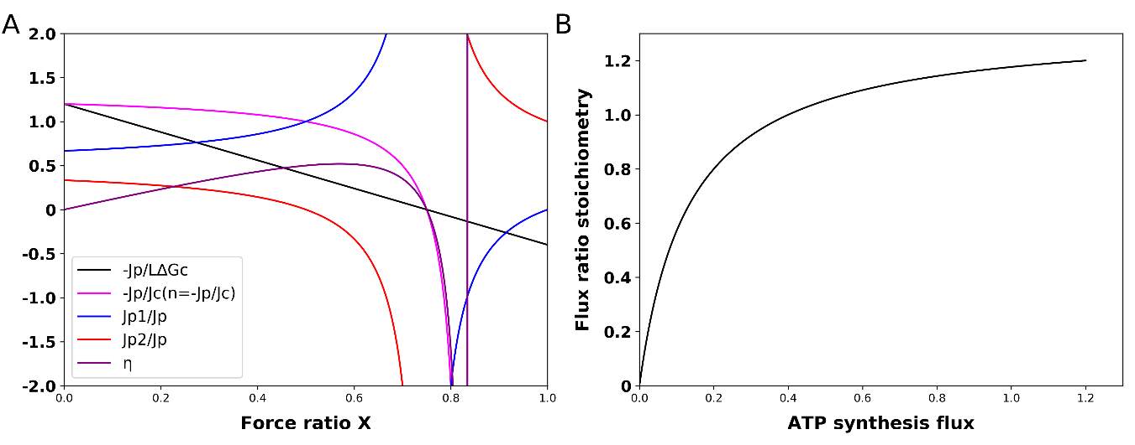

**Figure S2.** **(A)** Dependence of ATP synthesis flux, overall flux ratio, flux ratios through the two branches, variable flux-ratio stoichiometry n(=-Jp/Jc), and thermodynamic efficiency on the counteracting force ratio. The equation was used for the simulation of as function of force ratio X; the equation was used for the calculation of -Jp/ Jc; the equation / was used for the calculation of –Jp1/Jp; The formula / was used for the calculation of –Jp2/Jp; The equation was used for simulation of as function of force ratio X. **(B)** Flux ratio stoichiometry versus ATP synthesis. Increase of the variable stoichiometry n=(-Jp/Jc) with increasing ATP flux. At a force ratio of 0.75 the output flux of ATP synthesis reverts to ATP degradation, while catabolism continues. This corresponds to a car still using gasoline to try to move forward but being forced back downward due to gravity. Consequently, the stoichiometry and the thermodynamic efficiency become negative. At the force ratio of 0.83 also catabolism inverts. At this and higher force ratios, the model simulates reverse operation where ATP hydrolysis would drive reversal of catabolism, which is not often realistic. , L= 1, ∆Gc = 1The file named “figures” under the folder of “Codes” in the Github repository shows how this figure can be obtained.

*S2.2. Variable coupling*

ATP synthesis and catabolism are coupled to each other. This coupling has two aspects. First, at more intensive coupling the ratio of the ATP synthesis flux () to the catabolic flux () should increase. Second with more intensive coupling the catabolic flux should feel a stronger ‘backpressure’ by the Gibbs energy of ATP synthesis. This is expressed by the effect of the degree of coupling *q* in the following two equations (Kedem & Caplan, 1965):

*Z*>0, *q*>0, *L*>0, and X>0 represent the phenomenological stoichiometry, the degree of coupling, the catalytic capacity of catabolism, and the ratio of the counteracting Gibbs energy of anabolism to the driving Gibbs energy of catabolism, respectively. This expression does not describe reality precisely (reality is more nonlinear than this; Westerhoff and Van Dam, 1987), but it may still serve to illustrate qualitatively the roles played by the (Gibbs) energy, the phenomenon of ‘coupling’, stoichiometry, catalytic activity and the thermodynamic ‘forces’. The equations show that if per unit catabolic process more ATP is made (partly reflected by an increase in the phenomenological stoichiometry Z), both the backpressure effect and the flux ratio should increase. Stronger coupling and increased such stoichiometry Z have opposite effects on the excess thermodynamic force through which catabolism drives ATP synthesis; the former increases and the latter decreases this force.

When mapping these phenomenological equations onto the above equations describing our system of two parallel pathways making ATP, we find for the phenomenological stoichiometry Z a special weighted average of the stoichiometries of the two pathways:

Notably, unless the phenomenological stoichiometry differs both from the weighted average stoichiometry and from the flux ratio stoichiometry

Also the degree of coupling q depends on the stoichiometries of the two pathways as well as on their relative activities, but in a different way:

If there is complete coupling such as when there is only a single pathway, i.e. =1 or 0, then q=1 and Z always equals the flux stoichiometry n(X), i.e. ratio of growth rate to catabolic flux. Then Z functions as a true, i.e. constant stoichiometry. If the fraction equals zero or 1, i.e. if only pathway 1 or pathway 2 is active, the degree of coupling equals 1, and the phenomenological stoichiometry equals the stoichiometry of the pathway that is active. For in between 0 and 1, the phenomenological stoichiometry lies in between those of the two pathways, but the degree of coupling is lower than 1, showing that the gear shifting is accompanied by uncoupling. This reflects the possibility that at some force ratios the one pathway synthesizes ATP whilst the other operates in reverse mode and hydrolyzes the same amount of ATP. Net catabolism is then incompletely coupled to the net synthesis of ATP.

More generally, the equation for the rate of ATP synthesis ()

reflects that growth rate should be expected to increase with (i) the catalytic capacity of catabolism *L*, (ii) the magnitude of the Gibbs energy of catabolism (which is accordingly called the driving force for growth), (iii) the degree of coupling *q* (i.e. if there is less ATP diverted to maintenance or proton leakage and the coupling thereby increases, the growth rate should go up as well), and (iv) (at the lower force ratios, not at high force ratios where it will decrease due to increased effectiveness of the back pressure) the phenomenological stoichiometry Z. On the other hand the growth rate should decrease (v) with increasing back pressure from a higher Gibbs energy of growth relative to the Gibbs energy of catabolism ().

*S2.3. Variations in the phenomenological stoichiometry could improve ATP synthesis and growth*

Various authors have considered the variation of the output flux (here ATP synthesis *–Jp* or growth rate *-Ja*), yield (-*Ja/Jc),* and thermodynamic efficiency () with the Gibbs energy (‘force’) ratio . They did this for degrees of coupling equal to or smaller than 1 and then found that in the latter case the ratio of output flux to input flux decreased from Z to zero with increasing counteracting force ratio X, whilst Z was constant (both q and Z are independent of the force ratio X). This is concordant with the curve shown for in Figure S2.

Stucki also considered the dependence of the performance of mitochondrial oxidative phosphorylation on the degree of coupling q (Stucki, 1980). He considered the possibility of dual optimization, consisting of adjustments of both the force ratio X and the degree of coupling q so as to obtain optimality in terms of two rather than one criteria. This seemed to explain incomplete coupling in mammalian mitochondria (Stucki, 1980). It also led to the concept that microbial growth may be optimized for both efficiency and growth rate (Westerhoff et al., 1983; Westerhoff and Van Dam, 1987).

Little attention has been paid to dependencies on the stoichiometry Z: being a stoichiometry, Z was considered immutable. In this paper we break with this tradition and focus on variations of Z and subsequently on the, related, variations of *n(X)*, which we shall call ‘gear shifting’. Figure S3A shows how for four pathways that only differ in the magnitude of their phenomenological stoichiometry Z whilst having the same degree of coupling q, the ATP synthesis flux varies with the counteracting force ratio X. For the four phenomenological stoichiometries Figure S3B shows how the flux-ratio stoichiometry decreases with the increasing force ratio.

At low counteracting force ratio the pathway with the highest phenomenological stoichiometry Z makes most ATP, but with increasing force ratio its ATP synthesis flux decreases strongly, more so than for pathways with lower phenomenological stoichiometries. At a force ratio of 0.15, the ATP synthesis by the pathway with phenomenological stoichiometry of 4, dives below the ATP synthesis of the pathway with a Z of 2. The green line in Figure S3A shows that at force ratios below 0.29, having the four pathways operate in parallel is better than just operating one of them individually. In that range of force ratios, an ‘automatic’ tendency for the network to run flux through lower stoichiometry pathways, helps to keep the total flux of ATP synthesis high. At force ratios above 0.3 however, the network with all four pathways operative in parallel, turns to dismal performance due to the phenomenon that the pathway with the highest stoichiometry inverts its ATP synthesis flux into ATP hydrolysis. A futile, ATP hydrolyzing cycle hereby appears.

It should be better for the ATP synthesis if at the higher force ratios the pathway would switch between pathways, activating lower stoichiometry pathways whilst inactivating high stoichiometry pathways. At fixed values of X and q, the ATP synthesis flux is a parabolic function of the phenomenological stoichiometry Z with a maximum at:

, confirming that at small force ratios, increasing Z should enhance ATP synthesis, but not at high force ratios. Assuming that a regulatory network sets Z to this optimal value for each force ratio, the ATP synthesis flux should be given by:

The purple line in Figure S3A shows that indeed, such a ‘variomatic regulation’ of Z should produce a higher ATP synthesis flux than any other individual pathway with fixed settings of Z. The corresponding line in Figure S3B shows how the variomatic flux-ratio stoichiometry decreases with increasing force ratio. Figure S3C shows that the flux ratio stoichiometries increase with increase of ATP synthesis, again consistent with what should be optimal according to the FBA of Figure 1.

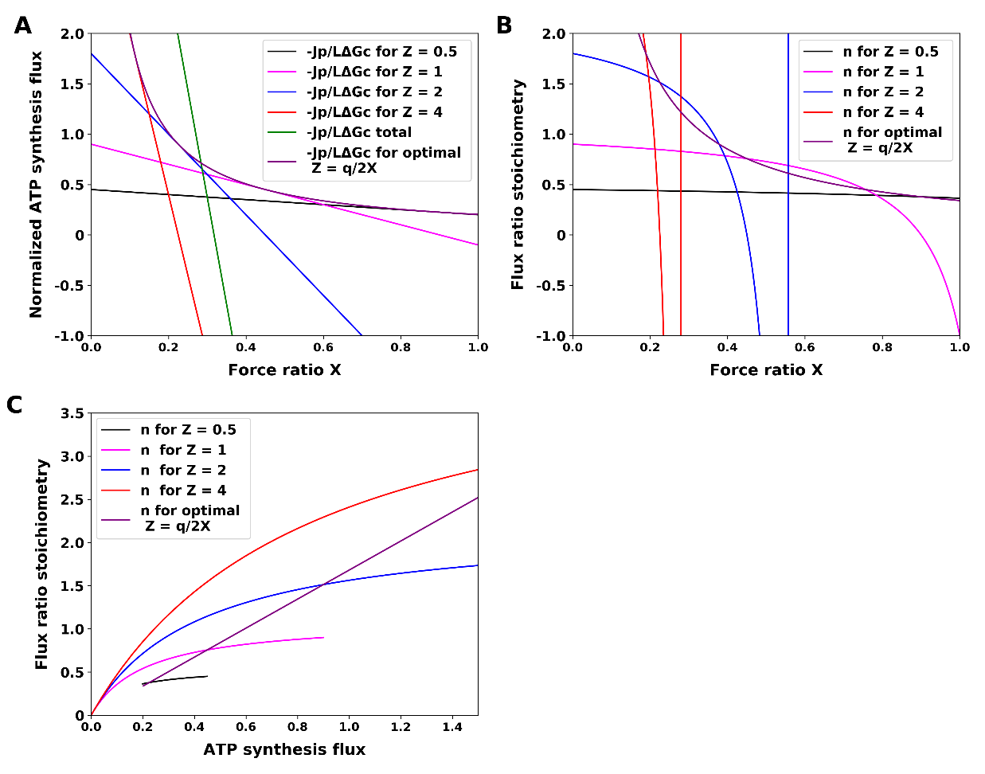

**Figure S3.** Variomatic gear shifting. (**A**) Normalized ATP synthesis flux versus force ratio at four magnitudes of the phenomenological stoichiometry Z, as well as their sum total and (dashed line) ATP synthesis for optimal ‘variomatic gear shifting’ and maximal ATP synthesis flux. The equation was used for simulation of as function of force ratio X. In these simulations, q=0.9 and various values of Z (0.5, 1, 2, 4, and the optimal variomatic q2/X) were used as indicated. ‘-Jp/LΔGc total was calculated as the sum of four. The file named “figures” under the folder of “Codes” in the Github repository shows how this figure can be obtained. (B) Flux ratio stoichiometry as a function of the force ratio. The equation was used for simulation of n. (**C**) Flux ratio stoichiometry versus ATP synthesis.

*S2.4. Gear shifting and varied relative pathway capacities could improve ATP synthesis and growth*

In the above we considered situations of different *phenomenologica*l stoichiometries at the same value of the coupling coefficient q. When gear shifting by changing the catalytic capacities of pathways with different stoichiometries, *i.e.* when gear shifting by changing the factor φ, one most often also changes the degree of coupling. Figure S7A plots the ATP synthesis flux versus the force ratio for various magnitudes of φ, at fixed magnitudes of the ATP stoichiometries n1 and n2 of the two pathways. Again, at low force ratios, the higher stoichiometry pathway produced more ATP synthesis than lower stoichiometry pathways, and at high force ratios (X>0.25) this inverted. Now however, as opposed to Figure S6A in which the degree of coupling was held the same for the different values of Z, all the lines intersect at a single point, implying that, if the degree of coupling were allowed to vary, it would make no sense *gradually* to shift to lower stoichiometry with increasing force ratio. At one critical force ratio it should be best to switch immediately from the highest to the lowest stoichiometry pathway (Figure S7). A corollary would be that there be no evolutionary advantage to having multiple pathways with multiple stoichiometries, such as one may find through analysis of the metabolic map of in *S. solfataricus*. Then two different stoichiometries should suffice to enable optimal adaptation of the ATP synthesis flux to the force ratio.

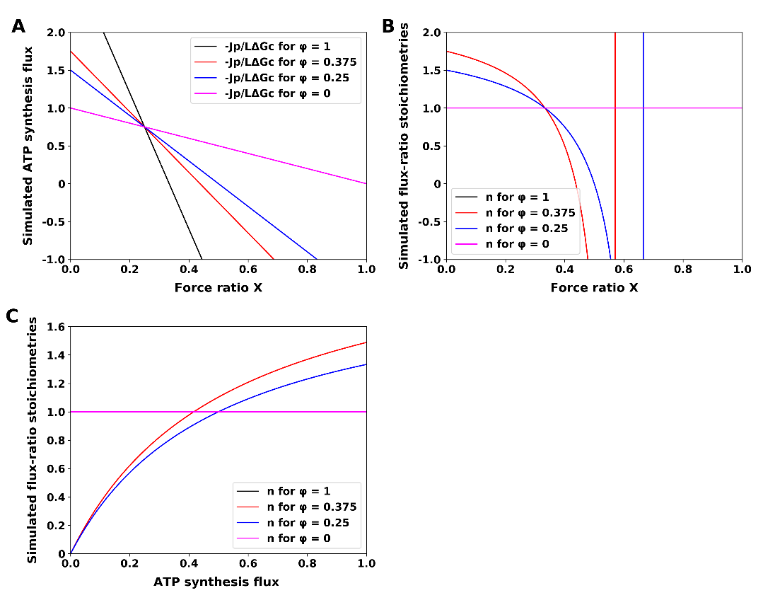

**Figure S7.** (**A**) Simulated ATP synthesis flux through a dual pathway (pathways 1 and 2 with two different ATP stoichiometries) as function of force ratio at various relative pathway capacities. In these simulations both Z and q varied as a function of φ, which was kept constant at any of four values, while X was varied. The equationwas used for simulation of as function of force ratio X. (**B**) Simulated flux-ratio stoichiometries as function of the force ratio. The equation was used for the simulation of n as function of force ratio. (**C**) Simulated flux-ratio stoichiometries as function of ATP synthesis flux. ,*L*= 1, *∆Gc* = 1 The file named “figures” under the folder of “Codes” in the Github repository shows how this figure can be obtained.

Above we showed that if two pathways take over the role of a single pathway, this has the effect of introducing a variable stoichiometry n(X). From this we infer that having multiple pathways should enable an organism effectively to regulate its pathway stoichiometry. Figure S8 therefore shows the variation of the flux of ATP synthesis with the force ratio for four values of the stoichiometry n. Again the ATP synthesis flux is best for high stoichiometry at low X and for low stoichiometry at high X. As when we varied the phenomenological stoichiometry at constant degree of coupling, the lines do not all intersect at a single point. The implication is that it should make sense for the cells to shift their stoichiometries from 4 to 3, to 2 and then 1 as indicated by the line labelled ‘gear’ in the figure. The organism should do this by activating one pathway and suppressing all the others, again to prevent futile cycling. The strategy corresponds to ‘automatic discontinuous gear shifting’ between integer gears settings, which differs from the ‘variomatic’ strategy, which is continuous.

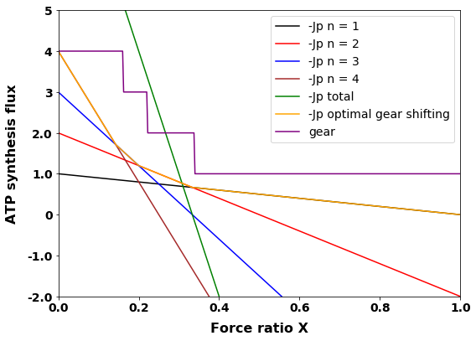

**Figure S8.** Discontinuous optimal gear shifting. ATP synthesis as function of counteracting force ratio for 4 different stoichiometries, all together, as well as the optimal gear shifting case with the corresponding gear settings. The equation was used for simulation of as function of force ratio X at four fixed values of n. In these simulations, n1, n2, n3 and n4 were taken equal to 1, 2, 3 and 4, = 0, *L*= 1, *∆Gc* = 1. Jp total is the sum of the four Jp’s. The yellow line (consisting of four smaller straight lines at angles with each other) represents the effect of operating always (i.e. at any force ratio X) only a single one of the four gears, i.e. the one with the highest flux of ATP synthesis. The difference of the optimal gear setting with that of Figure S6 is that the shifting is not continuous but only between integer values of Z as shown by the purple line labelled ‘gear’. The file named “figures” under the folder of “Codes” in the Github repository shows how this figure can be obtaine

*S3 Fermentation in S. solfataricus?*

*S3.1 Why there is no shift from respiration to lactate fermentation in S. solfataricus*

Many microorganisms can shift from fermentation to respiration. In *S. cerevisiae* (baker’s yeast) growing on ample glucose, for instance, fermentation to ethanol plus CO2 is the major pathway for Gibbs energy harvest, even under aerobic conditions. However, when glucose becomes limiting, a shift from fermentation to respiration occurs Verduyn et al., 1984; Gasmi et al., 2014). The organism shifts from low to high ‘gear’ (i.e. from low to high ATP/glucose stoichiometry). *L. lactis* lacks the possibility to change from fermentation to respiration when oxygen is present, but has alternatives to its main fermentation route to lactate. These alternatives run towards acetoin, acetate, diacetyl or butane diol and have different ATP yields (Hoefnagel et al., 2002), i.e. correspond to different gear settings.

*S. solfataricus* has been found to be an obligate aerobe Simon et al (2009) and Ulas et al (2012) suggest that it is unable to engage in any of these shifts. This could be because its genome does not encode enzymes that catalyze the corresponding flux (e.g. from pyruvate to lactate). In order to examine this possibility, it is not sufficient to show that the organism lacks lactate dehydrogenase, as there could be complex alternative metabolic routes enabling fermentation to lactate. We therefore used the genome-wide DNA-based metabolic map and asked for growth (i.e. we made the biomass production reaction the objective of a flux balance analysis). We found that the complete metabolic map with oxygen available to it could produce flux to biomass (Number 1 in Table S1), but that it could not grow when we blocked the reaction for importing oxygen (Number 1 in TableS1).

**Table S1** The fluxes computed for the genome wide metabolic network through the indicated reaction as objective function and with the changes indicated in the “Action” column to the reactions shown in the “Reaction_id” column. The (flux) yields are given in mol per mol glucose consumed, except for biomass, which is in units gram dry weight per hour. The file named “Simulation there is no shift from respiration to lactate fermentation in S. solfataricus” found in the Github repository under the folder name “codes” reproduces all the simulations.

|  |  |  |  |  |
| --- | --- | --- | --- | --- |
| Number | Reaction id | Action | Objective reaction | Flux yield |
| 1 | --- | --- | Biomass | 63 |
| 2 | T_flux_oxygen | Blocked | Biomass | 0 |
| 3 | T_flux_oxygen | Blocked | T_flux_(S)__lactic_acid | 0 |
| 4 | T_flux_oxygen | Blocked | T_flux_ethanol | 0 |
| 5 | T_flux_oxygen | Blocked | T_flux_ethanol | 0 |
| pyruvate_decarboxylase_to_acetaldehyde | Added |
| 6 | T_flux_oxygen | Blocked | T_flux_(S)__lactic_acid | 2 |
| prot_prot__lactate (protonation reaction of lactate to lactic acid) | Changed to reversible |
| 7 | T_flux_oxygen | Blocked | T_flux_ethanol | 0 |
| T_ABC__transporter_ethanol | Changed to reversible |
| 8 | T_flux_oxygen | Blocked | T_flux_ethanol | 2 |
| pyruvate_decarboxylase_to_acetaldehyde | Added |
| T_ABC__transporter_ethanol | Changed to reversible |
| 9 | T_flux_oxygen | Blocked | T_flux_ethanol | 2 |
| pyruvate_decarboxylase_to_acetaldehyde | Added |
| ethanol_diffusion | Added |
| 10 | T_flux_oxygen | Blocked | Biomass | 0 |
| prot_prot__lactate | Changed to reversible |
| 11 | T_flux_oxygen | Blocked | Biomass | 0 |
| pyruvate_decarboxylase_to_acetaldehyde | Added |
| ethanol_diffusion | Added |
| 12 | T_flux_oxygen | Blocked | Non-growth rate dependent maintenance ATP hydrolysis (NGAM) | 1 |
| prot_prot__lactate | Changed to reversible |

This would seem to explain the experimental observation that the organism is an obligate aerobe. Which genes is the organism missing then so as to prevent it to use fermentation to drive its growth? Are the enzymes producing or exporting lactate, and those producing ethanol plus carbon dioxide from pyruvate absent from the genome? We searched for the relevant enzymes (lactate dehydrogenase, pyruvate decarboxylase and alcohol dehydrogenase) and transporters (of lactate and ethanol). We found lactate dehydrogenase and alcohol dehydrogenase but not the standard pyruvate decarboxylase in the genome wide map of *S. solfataricus*. In order to examine why the organism would still not be able to ferment to lactate, we implemented a procedure that we call ‘Metabolic Task Analysis’ (MTA), i.e., we made flux through the lactic acid export reaction the objective function of an FBA. Again blocking the import of oxygen, we found that the lactic acid efflux was 0 (Number 3 in Table S1). We also made the alcohol dehydrogenase reaction the objective reaction and again found a zero flux (Number 4 in Table S1). The map does contain a pyruvate decarboxylase reaction, but this is not the standard reaction known from *S. cerevisiae*: it is coupled to the reduction of quinone and produces acetate rather than acetaldehyde. Anaerobically it should be difficult to recycle the quinol produced into the quinone required for this reaction. In order to examine whether this was the sole cause for the lack of ability to ferment to ethanol and CO2, we temporarily added the acetaldehyde producing pyruvate decarboxylase reaction to the map, and used the ethanol export reaction as the objective reaction, but FBA continued to show zero flux (Number 5 in Table S1). Apparently the chemical reactions as specified in the *S. solfataricus* metabolic map do not suffice for engaging in the fermentation reactions, neither the alcohol fermentation executed by *S. cerevisiae*, nor to the lactic acid fermentation executed by *L. lactis*.

We then checked how, according to the genome-wide metabolic map, lactate could be exported. The actual transport reaction specified by the map was for lactic acid together with protons. However, in the metabolic map, lactic acid could not be formed from the lactate produced by intracellular metabolism, as the deprotonation reaction from lactic acid to lactate was formulated as irreversible. This is highly unrealistic as carboxylates readily get protonated. We therefore turned this deprotonation reaction reversible (number 6 in Table S1). This did enable flux to extracellular lactate and thereby fermentation. We conclude that a more realistic version of the genome wide map of *S. solfataricus* did support fermentation from glucose to lactate. The corresponding flux pattern is shown in Figure S8.

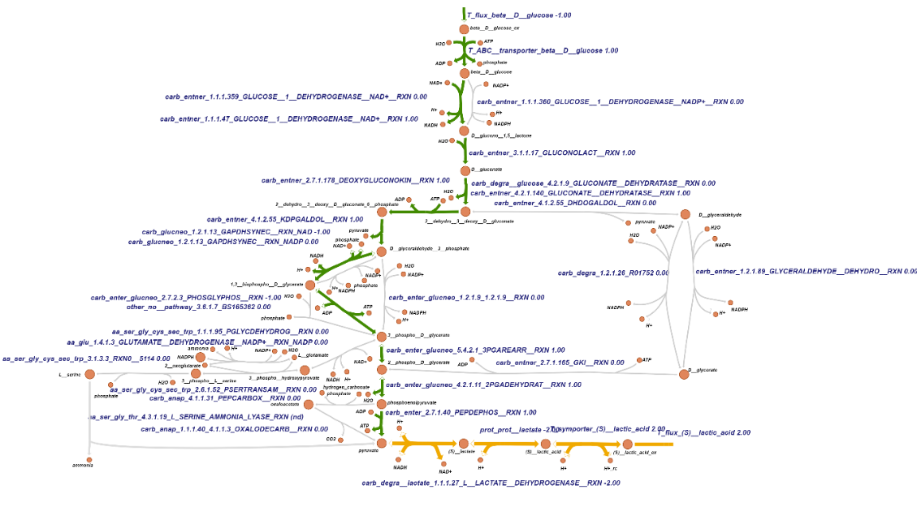

**Figure S8**. Visualization of the flux distribution when asking the GEMM for anaerobic lactic acid production on glucose and with a reversible lactate protonation reaction. Numbers next to each reaction identifier refer to steady-state flux in mmol gDW-1 h-1. The maximum uptake of extracellular glucose was fixed at 1 mmol gDW-1 h-1, the import of oxygen was blocked and the lactic acid export reaction was used as objective reaction for flux balance analysis. The file named “Simulation there is no shift from respiration to lactate fermentation in S. solfataricus” found in the Github repository under the folder name “codes” showed all the simulations. Gray color corresponds to zero flux, while gradients of green, brown, and yellow correspond to non-zero flux, and from green to brown the flux increased.

Next we made all protonation reactions in the genome wide map reversible but we still did not see ethanol fermentation. We then again turned to transport. The map’s transporter reaction for ethanol could only import ethanol into the cell. Since the transporter links this import of ethanol to the hydrolysis of ATP, such an assumed irreversibility is realistic for such a process. The absence of a possibility of ethanol to flow out of the cell is however unrealistic. Ethanol even more than water is fairly permeant through most biological membranes (Hannoun and Stephanopoulos, 1986), but then in a process not coupled to ATP synthesis. When we made the ATPase driven import of ethanol reversible, and repeated the flux balance analyses with ethanol export as objective (Number 7, 8 in Table S1) we obtained flux provided we added the pyruvate decarboxylase reaction to the map. Alternatively, adding a passive ethanol transport reaction produced flux through the ethanol export reaction too (Number 9 in Table S1). These fluxes still depended on the addition of the pyruvate carboxylase producing acetaldehyde however and should thereby be considered speculative.

We therefore returned to the realistic possibility for the cells to ferment glucose to lactic acid. For an organism to ‘seriously’ engage in such a process, it should be able to use it to drive its growth. Therefore we asked if the organism was able to grow anaerobically after again making the lactic acid de-protonation reaction reversible. Even though lactic acid could be produced, the answer was ‘No’ (Number 10 and 11 in Table S1).

Growth requires ATP in addition to Carbon in the form of pyruvate. We therefore used MTA to examine if the proposed fermentation pathway from glucose to lactate could yield any ATP: we made flux through the ATP maintenance reaction the task, i.e. took that as the objective in FBA. By forcing flux through the glucose uptake system, we found that fermentation in *S*. *solfataricus* could proceed in principle, but only with production of 1 ATP per glucose (Number 12 in Table S1) (The corresponding flux pattern is shown in Figure S8).

That ATP was produced may seem enigmatic as the metabolic pathway running from 1 glucose to 2 lactates consumed as many ATP’s as that it produced (Figure S8). In the genome-scale metabolic map (GEMM) of *S. solfataricus* by (Wolf et al., 2016), which we essentially used in our computation, 2 times. FBA predicted a flux pattern (Figure S8) in which 2 times 2 protons are extruded from the cell together with the 2 lactic acids produced from glucose (Table 1). These 4 protons flow back across the membrane through the H+-APase and drive the production of 1 ATP from ADP and phosphate.

Indeed, the gear setting of the lactic acid transporter in the metabolic map (GEMM) of *S. solfataricus* by (Wolf et al., 2016) equals 2 H+/lactic acid (i.e. 3 H+/lactate). How many protons are actually pumped out per lactic acid is uncertain for the lactic acid transporters of *S. solfataricus.* In many other genome wide metabolite maps, the transport reaction of lactic acid only takes 1 proton with it, which should drive little, but perhaps sufficient, ATP synthesis. And in some other models, the lactic acid transporter cannot pump any proton, and therewith not lead to ATP synthesis. Only when the gear setting is larger than this zero, fermentation to lactic acid should enable the cells to make the ATP required for biomass production. We checked the biomass production of S. solfataricus at different gear setting using the metabolic map. We found that even when the gear setting exceeds 1, it still cannot produce biomass. This means that some precursors necessary for the production of biomass cannot be produced in the absence of oxygen. Through adding import reaction for the component of the biomass composition equation one by one, and running FBA with biomass as an objective function, we indeed found that the biomass components coenzyme B12, norspermidine, norspermine, spermidine, thiamin diphosphate and ‘representative quinone’ could not be produced.

We also checked whether biomass could be produced after adding import reactions for these precursors. As these precursors are large and cannot be transported via diffusion, we assumed that their transport reactions would require ATP. We ran FBA again with the bound of glucose exchange reaction fixed at 1 mmol gDW-1 h-1 and biomass reaction as objective reaction. We found biomass can be produced when the gear setting exceeds 1. And it indeed showed that when the gear setting is 0, no biomass can be produced.

Next we checked whether it should be thermodynamically feasible for *S. solfataricus* to make ATP using the protons pumped out from lactic acid export system. The acid dissociation constant (*Ka*) of lactic acid of 0.14 mM approximately is defined by where [lactic acid], etc, represent the concentrations of the respective species in M (mol/L). *S. solfataricus* grows optimally at pH 2-4 but maintains its cytoplasmic pH at approximately 6.5 (She et al., 2001). In our calculation we will choose the pH of the medium to equal 3 and of the cytoplasm to equal 6.5. When any significant growth fermenting to lactic acid has taken place, the lactic acid in the medium should exceed 0.1 mM. The extracellular lactate may be neglected because the pKa exceeds the extracellular bpH. The lactic acid export reaction with a gear setting of *n* is the reaction

As this reaction must run to the right-hand side the lactate acid concentration in the cytoplasm should therefore fulfill the following condition:

Consequently:

, where we have neglected the membrane potential () dependent factor, as in extreme acidophiles the transmembrane electric potential tends to be small. This is far beyond the possible (pure water has a concentration of 55 M), for gear settings of 1 or higher. Negative gear settings would not generate the protonmotive force required to drive the ATP synthesis. Only positive gear settings far below 0.5 should be possible, but these would deliver only a very low ATP yield, probably insufficient to deal with the maintenance energy requirements, which should anyway be large for an extremophile like *S. solfataricus*. We conclude that although in principle gear settings of 1 or higher for the lactic acid efflux system would lead to ATP synthesis and thereby growth, these gear settings are thermodynamically incompatible with a forward flux through the export system. This then explains why the organism cannot ferment to lactate.

*S3.2. Alternative fermentation pathways would not yield ATP either*

Realistic fermentation pathways alternative to lactic acid fermentation might also be able to produce ATP and perhaps drive growth. Therefore, we checked if the GEMM supplemented with export reactions for all its metabolites can synthesize ATP from ADP and phosphate, with a blocked oxygen import reaction. We found (Figure S9) a flux pattern in which the non-growth associated maintenance (NGAM) flux is 0.4 mmol ATP gDW-1 h-1, and acetate, CO2, and propanol are produced. Compared to the cost of growth in terms of ATP hydrolysis of 27.3 mmol ATP/gDW (see under *Materials and Methods*), this would only sustain growth at a cell cycle time much in excess of 27.3/0.4=80 hours. In this condition, two of the new reactions (acetate and propanol export reactions) were active. There was no acetate export reaction in the original map, while there is a propanol transporter reaction (ATP + H2O + n__propanol_ex -- > ADP + n__propanol + phosphate). However, in this reaction propanol can only be transported from the extracellular medium into the cell and not in the opposite direction. Moreover, this propanol import reaction also cost 1 molecule of ATP. As propanol is a small molecule similar to ethanol one may expect it to be able to pass by simple diffusion through biological membranes, as acetic acid can. Adding acetic acid and propanol export reactions to the GEMM should therefore be reasonable and these fermentation pathways should therefore be considered possible.

We next examined whether the GEMM of *S. solfataricus* with added acetate and propanol export reactions, could sustain growth through fermentation. No biomass could be produced by the map when we blocked the import of oxygen and made biomass production the objective function of the FBA. As we had already shown that the acetate and propanol fermentations are able to produce ATP, this means that some precursors necessary for the production of biomass cannot be produced in the absence of oxygen. Through adding import reaction for the component of the biomass composition equation one by one, and running FBA with biomass as an objective function, we indeed found that the biomass components coenzyme B12, norspermidine, norspermine, spermidine, thiamin diphosphate and ‘representative quinone’ could not be produced

We also checked whether biomass could be produced after adding import reactions for these precursors. As these precursors are large and cannot be transported via diffusion, we assumed that their transport reactions would require ATP. We ran FBA again with the bound of glucose exchange reaction fixed at 1 mmol gDW-1 h-1 and biomass reaction as objective reaction. We found biomass synthesis flux to be predicted at 0.007 h-1. This suggests that fermentation should be possible when adding these precursors. However, the biomass yield for this fermentation mode should be more than 10 times lower than that computed for the aerobic condition.

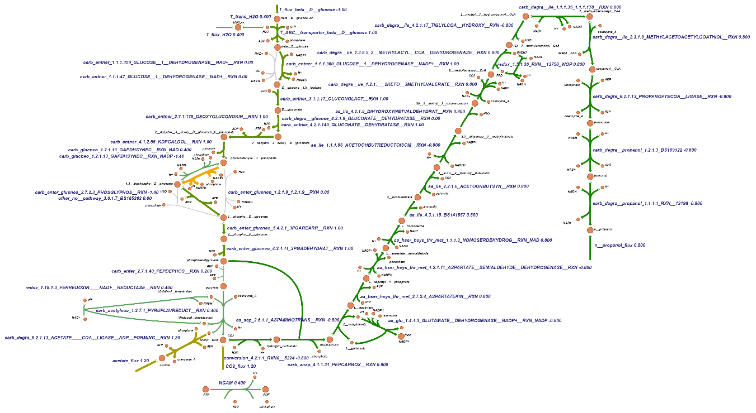

**Figure S9.** The flux of possible fermentation pathways. This flux pattern was obtained by adding the export reactions for all the metabolites, blocking the oxygen import reaction and asking for the generation of ATP. The bound of glucose exchange reaction was fixed at 1 mmol gDW-1 h-1, the NGAM (non-growth-rate-associated maintenance, a mere ATP hydrolysis) reaction was used as the objective function when running the FBA. The file named “Simulation there is no shift from respiration to lactate fermentation in S. solfataricus” found in the Github repository under the folder name “codes” showed all the simulations. Gray color corresponds to zero flux, while gradients of green, brown, and yellow correspond to non-zero flux, and from green to brown the flux increased.

We also checked whether there are electron acceptors alternative to molecular oxygen such as sulfur or nitrate to which the electron transfer chain of *S. solfataricus* might be accessible. If so, the organism might engage in anaerobic respiration with those electron acceptors to generate a proton motive force and hence ATP. We found that there are no reactions in the GEMM using nitrite as substrate or product. Apart from this we also checked the database KEGG and PATRIC and we did not find any experimental indications of this organism being able to use nitrite as electron acceptor. There is only one reaction involving nitrate, which is a nitrate transport reaction. Neither NO nor N2O exist in the map.

Some organisms, such as archaeoglobus (Vetriani, 2001), also use sulfate or sulfur as electron acceptor, in what is called sulfur respiration. Sulfur respiration has been proposed to be an ancestral mode of Gibbs energy provision as on early Earth there was no molecular oxygen available: (i) Volcanic S0 was one of the most abundant electron acceptors in the early atmosphere, and (ii) the capacity to reduce S0 to H2S is common among anaerobic, hyperthermophilic Archaea and Bacteria (Vetriani, 2001). Therefore, whether *S. solataricus* can use sulfate, sulfite or sulfur as electron acceptor when acquiring free energy is an attractive question.

The sulfur-sulfide redox couple has an apparent midpoint potential (Eo’; pH7) of -0.27 V, the sulfite-sulphide couple one of -0.12 V whereas the sulfate-sulfite couple has one of -0.52 V (Thauer et al., 1977) suggesting that *S. solfataricus* could harvest Gibbs energy by using sulfite as electron donor to reduce sulfur thereby producing sulfate and sulfide and harvesting some 2.5 kJ/mol electrons. Disproportionation of sulfite to sulfate and sulfide would even yield 4 kJ/mol electrons. We checked whether the metabolic map of *S. solfataricus* has entry/exit points for sulfite, sulfide or sulfate and found that only sulfate and sulfite entry exist as reactions in the map. Then we checked whether the reactions for sulfate reduction exist in the map. Before sulfate can be used as electron acceptor, it must be activated by ATP sulfurylase which uses ATP and sulfate to produce adenosine-5-phosphosulfate (APS). We did find the reactions in the map which can catalyze the reduction of sulfate to sulfide by NADPH (Figure S10), but at the cost of 2 ATP. Then we ran FBA again with the oxygen import reaction blocked but in the presence of sulfate, and ATP maintenance reaction as objective reaction, but we found there was no production of ATP. Since there is only one high energy phosphate bound could be used in ADP, we tried to see whether there would be another possible gear shift by making the reaction 2.7.7.4 use ADP as co-substrate (rather than ATP) and phosphate as product, rather than PP. After changing this reaction, we ran FBA again with ATP yield reaction as objective reaction, and there was no positive ATP yield again.

All these analyses suggest that there are no alternative respiration pathways that might enable fermentation with positive ATP yield, not even when allowing the organism to shift its gears. The experimental observation that *S. solfataricus* is obligate aerobe, is herewith understood on the basis of its genome sequence as expressed in its GEMM.

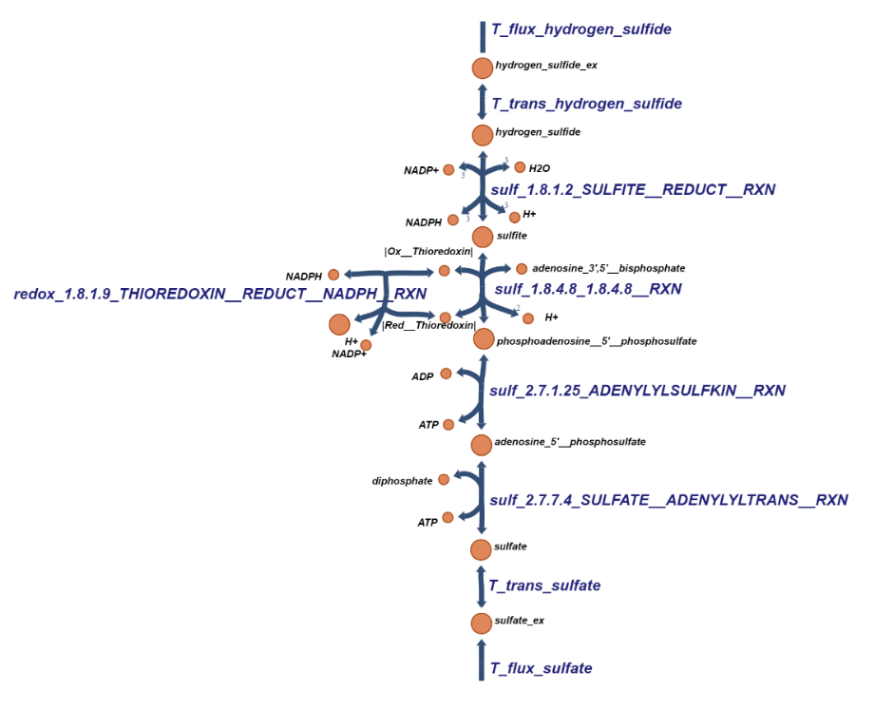

**Figure S10**. Pathway from sulfate to sulfide in *S. solfataricus*. This figure was drawn by the Escher software.

**References**

Gasmi, N., Jacques, P. E., Klimova, N., Guo, X., Ricciardi, A., Robert, F., and Turcotte, B. (2014). The switch from fermentation to respiration in Saccharomyces cerevisiae is regulated by the Ert1 transcriptional activator/repressor. Genetics 198(2), 547–560. doi: 10.1534/genetics.114.168609

Hannoun, B. J., and Stephanopoulos, G. (1986). Diffusion coefficients of glucose and ethanol in cell free and cell occupied calcium alginate membranes. *Biotechnol. Bioeng.* 28(6), 829-835.

Hoefnagel, M. H. N., Starrenburg, M. J. C., Martens, D. E., Hugenholtz, J., Kleerebezem, M., Van Swam, I. I., et al. (2002). Metabolic engineering of lactic acid bacteria , the combined approach : kinetic modelling , metabolic control and experimental analysis. Microbiology 148: 1003–1013. doi: 10.1099/00221287-148-4-1003

Kedem, O., and Caplan, S. R. (1965). Degree of coupling and its relation to efficiency of energy of conversion. Trans. Faraday Soc. 21, 1897–1911.

Orth, J. D., Thiele, I., and Palsson, B. Ø. (2011). What is flux balance analysis?. Nat. Biotechnol. 28(3), 245–248. doi: 10.1038/nbt.1614

Simon, G., Walther, J., Zabeti, N., Combet-Blanc, Y., Auria, R., Van Der Oost, J., and Casalot, L. (2009). Effect of O2 concentrations on Sulfolobus solfataricus P2. FEMS Microbiol. Lett. 299(2), 255–260. doi: 10.1111/j.1574-6968.2009.01759.x

She, Q., Singh, R. K., Confalonieri, F., Zivanovic, Y., Allard, G., Awayez, M. J., et al. (2001). The complete genome of the crenarchaeon Sulfolobus solfataricus P2. Biological Sciences 98(14), 7835–7840. doi: 10.1073/pnas.141222098

Stucki, J. W. (1980). The thermodynamic-Buffer Enzymes. Eur. J. Biochem. 109, 257–267. doi: 10.1111/j.1432-1033.1980.tb04791.x

Thauer, R., Jungermann, K., and Decker, K. (1977). Energy conservation in chemotrophic anaerobic bacteria. Bacteriol. rev. 41(1), 100-180. doi: 10.1128/mmbr.41.3.809-809.1977

Ulas, T., Riemer, S. A., Zaparty, M., Siebers, B., and Schomburg, D. (2012). Genome-Scale Reconstruction and Analysis of the Metabolic Network in the Hyperthermophilic Archaeon Sulfolobus Solfataricus. PLoS ONE 7(8). https://doi.org/10.1371/journal.pone.0043401

Vetriani, C. (2001). Archaea, Origin of. Encyclopedia of Biodiversity 1, 218-226. doi: 10.1016/B978-0-12-384719-5.00177-5

Verduyn, C., Zomerdijk, T. P. L., Dijken, J. P. Van, and Scheffers, W. A. (1984). Continuous measurement of ethanol production by aerobic yeast suspensions with an enzyme electrode. Appl. Microbiol. Biotechnol. 19, 181–185. doi: 10.1007/BF00256451

Westerhoff, H. V., Hellingwerf, K., and Van Dam, K. (1983). Thermodynamic efficiency of microbial growth is low but optimal for maximal growth rate. Proc. Natl. Acad. Sci. U S A. 80, 305–309. doi: 10.1073/pnas.80.1.305

Westerhoff, H. V., and Van Dam, K. (1987). Thermodynamics and control of biological free-energy transduction. Elsevier, Amsterdam. doi: 10.15490/fairdomhub.1.datafile.4954.1

Wolf, J., Stark, H., Fafenrot, K., Albersmeier, A., Pham, T. K., Müller, K. B., et al. (2016). A systems biology approach reveals major metabolic changes in the thermoacidophilic archaeon Sulfolobus solfataricus in response to the carbon source L-fucose versus D-glucose. Mol. Microbiol. 102(5), 882–908. doi: 10.1111/mmi.13498

Zhang, Y., Kouril, T., Snoep, J. L., Siebers, B., Barberis, M., and Westerhoff, H. V. (2017). The peculiar glycolytic pathway in hyperthermophylic archaea: Understanding its whims by experimentation in silico. Int. J. Mol. Sci. 18(4), 876. doi: 10.3390/ijms18040876